# ONLINE MOVIE TICKET BOOKING MANAGEMENT SYSTEM

## A MINI PROJECT REPORT

***Submitted by***

**MONISH M**

**21MIS0270**

# 

# NITHEESH T

**21MIS0401**



***in partial fulfilment for the award of the degree***

**of**

## MASTER OF TECHNOLOGY (INTEGRATED)

**in**

**SOFTWARE ENGINEERING**



**SCHOOL OF INFORMATION TECHNOLOGY AND ENGINEERING**

**VIT UNIVERSITY: VELLORE 632 014**

**APRIL,2023**

**BONAFIDE CERTIFICATE**

Certified that this project report “ONLINE MOVIE TICKET BOOKING MANAGEMENT SYSTEM” is the bonafide work of “MONISH M{21MIS0270), NITHEESH T(21MIS0401)” who carried out the project work under my supervision.

**SIGNATURE**

**DR G. GUNASEKARAN**

**Associate Professor Sr.**

**Department of Smart Computing**

**School of Information Technology and Engineering**

# ABSTRACT

The project objective is to book cinema tickets in online. The Ticket Reservation System is an Internet based application that can be accessed throughout the Net and can be accessed by anyone who has a net connection. This application will reserve the tickets. This online ticket reservation system provides an application for a cinema hall where any user of internet can access it. User is required to login to the system and needs any kind of payment mode for booking the tickets. The application provides complete information regarding currently running movies on all the screens with details of show timings, available seats. The ticket can be cancelled if needed. Our online tickets reservation system is one of the best opportunities for those who cannot afford enough time to get their tickets reserved standing in long queues.

**TABLE OF CONTENT**

|  |  |  |
| --- | --- | --- |
| **CHAPTER** | **NAME OF CHAPTER** | **PAGE** |
|  | **ABSTRACT** | **III** |
|  | **TABLE OF CONTENT** | **IV** |
|  | **LIST OF ABBREVIATIONS** | **VIII** |
|  | **LIST OF TABLES** | **IX** |
|  | **LIST OF FIGURES** | **XI** |
|  |  |  |
| **01** | **Introduction** | **01** |
| **02** | **Software development life cycle model** | **02** |
| **03** | **Requirement Phase**  3.1 Problem Statement  3.2 Requirement  3.2.1 Hardware Requirement  3.2.2 Software Requirement  3.3 Complete Project schedule  3.4 Literature Survey  3.5 System Requirement  3.5.1 Functional Requirement  3.5.2 Non-Functional Requirement  3.6 Initial level Business Model  3.7 Initial level Use case description  3.8 Glossary of the online ticket booking system | 04  04  04  04  05  06  08  08  09  10  11  15 |
| **04** | **Analysis Phase**  4.1 Analysis & Refinement of problem statement  4.2 Analysis & Refinement of hardware and software requirement  4.3 Analysis & Refinement of Initial level Business Model  4.4 Five step analysis  4.5 Analysis & Refinement of functional and non-functional requirement  4.6 Storyboard | 17  17  19  35  39  41 |
| **05** | **Design Phase**  5.1 Architecture of the online movie ticket booking system  5.2 Modules of the online movie ticket booking system  5.3 Activity diagram for online movie ticket booking system  5.4 State chart diagram for online movie ticket booking system | 45  46  48  52 |
| **06** | **Vision Document**  6.1 Introduction  6.1.1 Purpose of The Vision Document  6.1.2 Product Overview  6.1.3 References  6.2 User Description  6.2.1 User/Market Demographics  6.2.2 User Profile  6.2.3 User Environment  6.2.4 Key User Needs  6.2.5 Alternatives and Competition  6.3 Product Overview  6.3.1 Product Perspective  6.3.2 Product Position Statement  6.3.3 Summary Capabilities  6.3.4 Assumption and Dependency  6.3.5 Cost and Pricing  6.4 Feature Attribute  6.5 Product Feature  6.5.1 System Feature  6.5.2 Communication Feature  6.5.3 Emergency Feature  6.6 Exemplary Use case  6.7 Other Product Requirement  6.7.1 Applicable Standards  6.7.2 System Requirements  6.7.3 Licensing, Security  6.7.4 Performance Requirements  6.8 Documentation Requirement  6.8.1 User Manual  6.8.2 Online Help  6.8.3 Installation Guide,  Configuration, And Read Me File  6.9 Glossary | **55**  55  55  55  56  56  57  57  57  58  59  59  59  60  60  61  61  62  62  62  63  63  64  64  64  65  66  66  67  67  67  69 |
| **07** | **Supplementary Document**  7.1 Introduction  7.1.1 Purpose  7.1.2 Scope  7.1.3 Definition, Acronyms And  Abbreviation  7.1.4 Reference  7.2 Functional Requirements  7.3 Usability  7.4 Reliability  7.5 Performance  7.6 Supportability  7.7 Design Constraints  7.8 Documentation Requirements  7.9 Purchased Components  7.10 Interface  7.10.1 User Interface  7.10.2 System Interface  7.10.3 Hardware Interfaces  7.10.4 Software Interfaces  7.10.5 Communication Interfaces  7.11 Licensing and Security Requirements  7.12 Legal, Copyright and Other Notices  7.13 Applicable Standards  7.14 Internationalization and Localization  7.15 Physical Deliverables  7.16 Installation and Deployment | **70**  70  70  70  71  71  72  73  74  74  75  75  77  78  78  78  79  79  79  80  80  81  81  82  82  83 |
| **08** | **Conclusion and Future work** | **84** |
| **09** | **References** | **85** |

**LIST OF ABBREVIATIONS**

|  |  |  |
| --- | --- | --- |
| **SNO** | **ABBREVIATION** | **FULLFORM** |
| 1 | SDLC | Software Development Life Cycle |
| 2 | SRS | System Requirement Specification |
| 3 | WBS | Work Breakdown Structure |

**LIST OF TABLES**

|  |  |  |
| --- | --- | --- |
| **TABLE NUMBER** | **NAME OF TABLE** | **PAGE** |
| Table 3.1 | Schedule of the project | 05 |
| Table 3.2 | Use case scenario for Login/Logout | 11 |
| Table 3.3 | Use case scenario for Search movie | 11 |
| Table 3.4 | Use case scenario for Add movie/show | 11 |
| Table 3.5 | Use case scenario for Modify show/movie | 12 |
| Table 3.6 | Use case scenario for Cancel movie/show | 12 |
| Table 3.7 | Use case scenario for Create booking | 12 |
| Table 3.8 | Use case scenario for Make payment | 13 |
| Table 3.9 | Use case scenario for View booking | 13 |
| Table 3.10 | Use case scenario for Cancel booking | 13 |
| Table 3.11 | Use case scenario for Send notification | 14 |
| Table 3.12 | Use case scenario for Change language | 14 |
| Table 3.13 | Use case scenario for Register | 15 |
| Table 3.14 | Glossary of the system | 15 |
| Table 4.1 | Refined Use case scenario for Register | 20 |
| Table 4.2 | Refined Use case scenario for Login/Logout | 21 |
| Table 4.3 | Refined Use case scenario for Search movie | 22 |
| Table 4.4 | Refined Use case scenario for Add movie/show | 23 |
| Table 4.5 | Refined Use case scenario for Modify show/movie | 24 |
| Table 4.6 | Refined Use case scenario for Cancel movie/show | 25 |
| Table 4.7 | Refined Use case scenario for Create booking | 26 |
| Table 4.8 | Refined Use case scenario for Make payment | 28 |
| Table 4.9 | Refined Use case scenario for View booking | 30 |
| Table 4.10 | Refined Use case scenario for Cancel booking | 31 |
| Table 4.11 | Refined Use case scenario for Send notification | 32 |
| Table 4.12 | Refined Use case scenario for Change language | 34 |
| Table 4.13 | Gain agreement | 35 |
| Table 4.14 | Stakeholder and User | 36 |
| Table 4.15 | Constraints Imposed | 38 |
| Table 6.1 | Summary Capabilities | 60 |
| Table 6.2 | Feature Attribute | 62 |
| Table 6.3 | Glossary for vision document | 69 |

**LIST OF FIGURES**

|  |  |  |
| --- | --- | --- |
| **FIGURE** | **NAME OF FIGURE** | **PAGE** |
| Fig 2.1 | Waterfall model | 03 |
| Fig 3.1 | Gantt chart | 05 |
| Fig 3.2 | Use case Diagram | 10 |
| Fig 4.1 | Refined Use case Diagram | 19 |
| Fig 4.2 | Fish bone diagram | 36 |
| Fig 4.3 | Pareto Graph | 36 |
| Fig 4.4 | System boundary | 37 |
| Fig 4.5 | Storyboard 1 | 41 |
| Fig 4.6 | Storyboard 2 | 41 |
| Fig 4.7 | Storyboard 3 | 42 |
| Fig 4.8 | Storyboard 4 | 42 |
| Fig 4.9 | Storyboard 5 | 43 |
| Fig 4.10 | Storyboard 6 | 43 |
| Fig 4.11 | Storyboard 7 | 44 |
| Fig 5.1 | Architecture for Online movie ticket booking system | 45 |
| Fig 5.2 | Activity diagram for Online movie ticket booking system | 48 |
| Fig 5.3 | Activity diagram for Login | 49 |
| Fig 5.4 | Activity diagram for Create booking | 49 |
| Fig 5.5 | Activity diagram for Make payment | 50 |
| Fig 5.6 | Activity diagram for Add show | 50 |
| Fig 5.7 | Activity diagram for Change language | 51 |
| Fig 5.8 | State chart diagram for Online movie ticket booking system | 52 |
| Fig 5.9 | State chart diagram for Login | 52 |
| Fig 5.10 | State chart diagram for Create booking | 53 |
| Fig 5.11 | State chart diagram for Make payment | 53 |
| Fig 5.12 | State chart diagram for Add show | 54 |
| Fig 5.13 | State chart diagram for Change language | 54 |
| Fig 6.1 | Overview of product perspective | 59 |

**CHAPTER 01**

**INTRODUCTION**

**INTRODUCTION**

The online movie ticket booking system has revolutionized the way movie-goers purchase tickets for their favourite movies. Gone are the days of standing in long lines at the box office or making phone calls to book tickets in advance. With the online movie ticket booking system, movie-goers can now purchase tickets quickly and easily from the comfort of their homes or on-the-go using their smartphones. The system offers a user-friendly and intuitive interface, making it easy for movie-goers to search for movies, theatres, showtimes, and available seats. The online movie ticket booking system provides a highly convenient solution for movie-goers, allowing them to avoid the hassle and inconvenience of long lines and wait times.

With the system, movie-goers can view available showtimes, compare prices, and choose the best seats for their preferred movie. The system also integrates with various payment gateways to provide a secure and convenient way to make payments, making the entire ticket booking process quick, easy, and hassle-free. For movie theatres and cinema chains, the online movie ticket booking system provides a cost-effective solution for ticket booking and management.

The system eliminates the need for manual ticket booking processes, reducing the costs associated with ticket printing and distribution. The system also provides valuable insights into movie-goer behaviour and preferences, enabling movie theatres to make data-driven decisions to improve their offerings and increase customer satisfaction. The online movie ticket booking system is designed to provide a seamless and user-friendly experience for both movie-goers and movie theatres.

The platform offers a range of features, including real-time updates on available seats, the ability to save favourite theatres and showtimes, and personalized recommendations based on movie-goer preferences. With the system, movie theatres can offer an enhanced customer experience, allowing movie-goers to choose their seats and make bookings at any time, from any location. In conclusion, the online movie ticket booking system is a highly valuable tool for both movie-goers and movie theatres.

The system provides a convenient, secure, and cost-effective solution for ticket booking and management, while offering a user-friendly and intuitive experience for movie-goers. With the online movie ticket booking system, movie-goers can purchase tickets quickly and easily, while movie theatres can reach a wider audience and increase their ticket sales

**CHAPTER 02**

**SDLC [1]**

**SDLC**

For a project first we need to choose the Software life cycle model. We choose the waterfall life cycle model. Waterfall model is simple and easy to understand and use. As each stage has a clear set of objectives and a specific timeline, the Waterfall model helps to control the budget and schedule of the project. The sequential nature of the Waterfall model provides a clear documentation trail. The Waterfall model provides better control and management as each stage is completed before moving on to the next. Each stage of the Waterfall model has a clear set of objectives, making it easier to measure progress and success.

The stages of the Waterfall model are as follows:

**Requirements Gathering and Analysis:** In this stage, the requirements for the project are gathered and analysed. The requirements are documented (SRS [2]) and agreed upon with the client.

**Planning:** Estimating the budget, scheduling the work to employees, tracking the progress of the project.

**Design:** In this stage, the design of the solution is created, including the architecture, system design, and component design.

**Implementation:** The design is then translated into code and the solution is developed in this stage. Testing: In this stage, the solution is thoroughly tested to ensure that it meets the requirements and works as expected.

**Testing*:*** All the units developed in the implementation phase are integrated into a system after testing of each unit. The software designed, needs to go through constant [software testing](https://www.toolsqa.com/software-testing/software-testing/) to find out if there are any[flaws or errors.](https://www.toolsqa.com/software-testing/istqb/error-defect-failure/) Testing is done so that the client does not face any problem during the installation of the software*.*

**Deployment and Maintenance:** The solution is deployed and made available for use in this stage. After deployment, the solution is maintained and any necessary updates and changes are made.

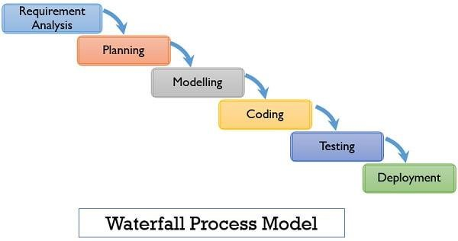

Fig 2.1: Waterfall Model

**CHAPTER 03**

**REQUIREMENT PHASE**

**3.1 PROBLEM STATEMENT**

The system must have a simple and intuitive interface that allows users to quickly find and purchase tickets for the movies of their choice. In addition to providing a secure and reliable platform for purchasing movie tickets, the online movie ticket booking system must also provide an administration panel that allows authorized personnel to manage the system and monitor transactions. The system must have a simple and intuitive interface that allows users to quickly find and purchase tickets for the movies of their choice. People love to get some cashback. We can give more cashback than the existing system. We can also give some special coupon for the regular customer which most of the existing system fail to give. Most of the system does not have real time booking. That means some system takes the customer to payment process then the booking gets failed. In such cases payment only may be carried out without seat booking. So, we need real time booking. Some of the existing system cost charges for online booking. We can remove that in our new management system. Some system provides only limited seat booking. These are the drawbacks of existing system. We should enable cancel booking option. So, that customer will get their refund. We have a challenge to handle the multiple booking at the same time. Accurate information should be passed to the customer. User interface should be easy and quickly accessible.

**3.2 HARDWARE AND SOFWARE REQUIREMENTS**

**3.2.1 HARDWARE**

* Computer systems (desktops, laptops) with a minimum of 4GB of RAM and a fast processor.
* Database servers (such as MySQL, Oracle, etc.) to store user, theatre, and movie information.

**3.2.2 SOFTWARE**

* Operating system (such as Windows, Linux, IOS etc.).
* Database management software (such as MySQL, Oracle, etc.).
* Payment Gateway Integration: PayPal, Stripe, Authorize.net, Skrill
* Front-End Development: HTML, CSS, JavaScript, React, AngularJS, Vue.js
* Software development tools and platforms (such as Java, .NET, etc.) to develop the application.

**3.3 COMPLETE PROJECT SCHEDULE**

A project schedule indicates what needs to be done, which resources must be utilized, and when the project is due. It is a timetable that outlines start and end dates and milestones that must be met for the project to be completed on time. The project schedule is often used in conjunction with a [work breakdown structure (WBS[3])](https://www.wrike.com/project-management-guide/glossary/#wbs) to distribute work among team members. The project schedule should be updated regularly to gain a better understanding of the project's status.

Table 3.1: Schedule of the project

|  |  |  |
| --- | --- | --- |
| **PHASE** | **START DATE** | **END DATE** |
| REQUIREMENT ANALYSIS | 07/12/2022 | 23/12/2022 |
| PLANNING | 26/12/2022 | 16/01/2023 |
| DESIGN | 17/01/2023 | 31/01/2023 |
| IMPLEMENTATION | 01/02/2023 | 10/03/2023 |
| TESTING | 13/03/2023 | 31/03/2023 |
| DEPLOYMENT | 03/04/2023 | 15/04/2023 |

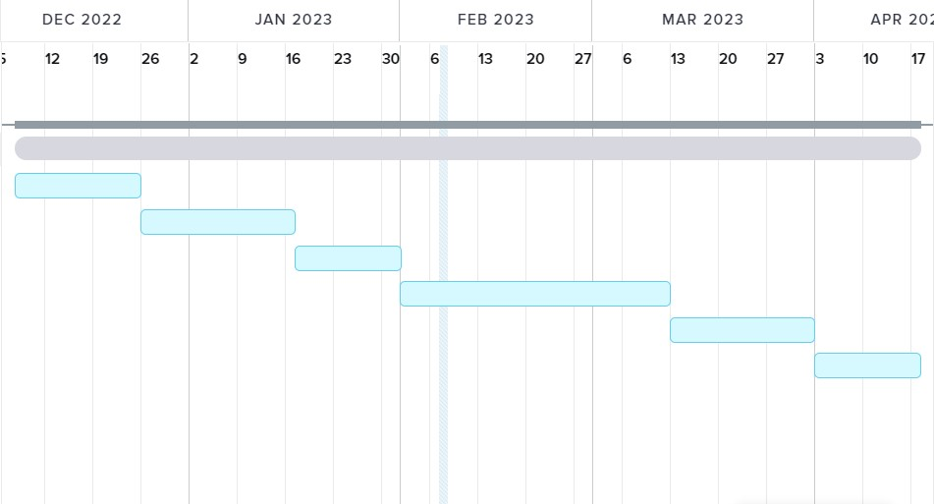

Fig 3.1: Gantt chart

**3.4 LITERATURE SURVEY WORK**

Mobiles phones play a vital role in our day-to-day life and their revolution has brought numerous changes not only in professional life but also personal lives of people across the globe. Initially, mobile phones were used for communication purpose, but with the advanced developments we are now using applications directly. This paper focuses and presents a novel application (app) named Advance Movie Ticketing System (AMTS) for online booking of movie tickets, followed by many other facilities also. Once the ticket is booked, a secured QR code is generated which is to be used at the ticket verification and authentication at various Cinema halls. By this application the physical transactions and the redundant physical checks may be reduced to some extent.[1]

This research is an online movie ticket reservation basically made for providing the customers ample opportunity to make movie reservation booking anywhere and anytime to book for desired but available seat(s) in a movie hall and in a specified seating position. Information about the movies will be online, so the user easily gets more details about the movies released and then make a choice either to buy the ticket or cancel an already placed order at a specified time to the show. This is being implemented using an object-oriented software approach through the development of an app and an internet-based platform thereby overcoming the traditional movie reservation approach in cinemas.[2]

In this era of technology everything is going online weather it is shopping household items or buy flats or resident. Enormous amount of business is going on the internet and online. Our project is also based on this concept, which is Online Movie Ticket Booking. You can call it whatever you want but the focus is to provide the user a facility to book movie ticket right from their homes according to their plans. User can also buy tickets for friends and family. Reserve seats, Check the cinema population status whether its full or empty, check for booked seats, number of seats and information about the cinemas. Info about the movies. Search for movies, cinemas, ticket fairs, discounts offer which is included in our online buying system.[3]

Movie Ticket Booking System is an online based application that can be accessed through the internet via a mobile device like phone, tablet and laptop etc by anyone at any time. This application is responsive and will help reserve tickets. Users are required to login to the system to book for ticket and make payment via e-payment system options. Watching movies with family and friends in theatres is one of the best mediums of entertainment after having a hectic schedule. But all this excitement vanishes after standing in hours in long queues to get tickets booked hence this automated system. The system provides complete information regarding currently running movies on all the screens with details of show timings, available seats. Ticket reservations are done using e-payment system and can be cancelled if need be. These online tickets reservation system is one of the best opportunities for those who cannot afford enough time to get their tickets reserved standing in long queues. People can book tickets online at any time of day or night at their pace. The application was developed using (SSAD) methodology using the following technologies PHP as the front end and MYSQL at the back-end JavaScript for form validations.[4]

SM Cinemas is one of the largest cinema chains in the country. SM has applied an online ticketing system in which users could reserve and buy tickets on their website. This study focuses on the usability of the SM Cinema website. Nine respondents were chosen to participate in the usability testing. Results show that the users were satisfied with the website's text and the activities done on the website are straightforward. However, the website was inefficient and users were unsatisfied with the layout of information presented. Moreover, users found difficulty when using the website for the first time. The users were also unsatisfied with some of the features and suggested numerous improvements. Recommendations were made and proposed in order to improve upon the usability of the website.[5]

With the rapid development of Internet, people's daily life has basically been inseparable from the network, and network development to today, has been to everywhere in the era of computing time, all sectors have been increasing their use of network services, to create new opportunities for themselves. After the Internet, without purpose, whether individuals or businesses, both consumers and manufacturers, are made on the network of hope, this new hope is to get through the network of the best things the cheapest, most practical to find the fastest information, the most profitable products to sell up. As people's lives getting better, but also many lifestyle changes. But the movie still has not changed preferences. Changed only place to see it. Since the film is more and more people see more votes to sell more and more people queuing, many people hated queue would rather buy a VCD or DVD at home look. But go to the movies and watching DVDs at home or feel very different.[6]

The present work is intended to provide a solution through the development of a chatbot using the Watson assistant and Node-RED UI for booking movie tickets. It ensures error-free booking of tickets without human agent intervention smoothly even during peak hours. It saves time and makes the process much easier for the customer as well as for the service provider by eliminating the elongated process starting from waiting in the queue of booking counter to getting the answers to repetitive queries. A web-based conversational flow is generated by only clicking on an URL from any electronic gadget with internet access.[7]

Our project simplifies movie ticket booking through a user-friendly interface. It uses PHP and SQL Server for front-end and back-end, respectively. Forms with verification ensure accuracy. The system is reliable and running satisfactorily at Audi theatres, offering combo packs for an integrated experience. Users can register via a form, and access rights are granted to installed users. The project benefits any firm seeking to enhance safety and streamline ticket booking. [8]

|  |  |
| --- | --- |
| |  | | --- | |  | |

Online movie booking has become popular due to technology and digitalization, saving time, and providing convenience. Server problems and transaction failures are major issues due to increased traffic. Our proposed research paper addresses these issues by using Node JS and Mongo DB connectivity. Additional features include mailing movie reviews and trailers and showing screen orientation. We designed a questionnaire for trustworthy reviews, cross-checked by the editorial team before publishing. Our advanced online movie booking system rectifies previous issues and adds new features.[9]

The movie industry has not changed much despite lifestyle changes and better business practices. Many still queues for cinema tickets or buy DVDs. E-services provide a trendy way to book and reserve tickets online for cinemas, airports, hotels, and bus stations. This research paper focuses on developing an online booking system for FLOW Entertainments cinema house. We used HTML, CSS, and JavaScript for the front-end, PHP for the scripting language, and MySQL as the back-end database. We implemented the system using XAMPP package with Apache as the server, and used NetBeans and Dreamweaver CSS for development. The system was successfully tested on a computer with 4GB RAM.[10]

|  |
| --- |
|  |

* 1. **SYSTEM REQUIREMENT**
     1. **FUNCTIONAL REQUIREMENT**

1. Movie searching: The system should display a list of currently available movies (with the language that is released), their descriptions (this includes the genre, list of the case, etc.,), showtimes, and available seats.

2. Seat assignment: Users should be able to select their preferred seats and view a map of the theatre layout.

3. Payment processing: The system should support multiple payment methods and process payments securely.

4. Confirmation of ticket purchase: The system should send a confirmation of the ticket purchase to the user via email or SMS.

5. Ticket management: Users should be able to view or cancel their tickets.

6. Theatre management: The system should allow theatre managers to update movie listings, showtimes, and seating arrangements.

7. Offer: Any offer that is applied during the booking must affect the price of the ticket accordingly, coupons, referral codes are also included.

8. Social sharing: The system should allow users to share their booking details on social media platforms to increase brand awareness and user engagement.

9. Multiple languages and currencies: The system should be able to support multiple languages and currencies to cater to a diverse user base.

10. Loyalty programs: The system should have provisions for loyalty programs to incentivize repeat bookings and increase customer retention.

11. User registration and login: Users should be able to create an account, log in, and manage their profile information.

* + 1. **NON-FUNCTIONAL REQUIREMENTS**

1. User experience: The system should have a user-friendly interface and be easy to navigate.
2. Performance: The system should be fast and responsive, with minimal downtime.
3. Scalability: The system should be able to handle increasing numbers of users and transactions without degradation in performance.
4. Reliability: The system should be dependable, with minimal errors or crashes.
5. Compatibility: The system should be compatible with different devices and web browsers.
6. Accessibility: The system should be accessible to users with disabilities, including those using assistive technologies.
7. Data privacy: The system should protect user data and comply with relevant privacy regulations.
8. Compliance: The system should comply with relevant legal and regulatory requirements.
9. Integration: The system should integrate with existing systems, such as accounting and reporting systems.
10. Maintenance: The system should be maintainable, with clear documentation and easy-to tools for making updates and improvements.

**3.6 BUSSINESS USE CASE DIAGRAM**

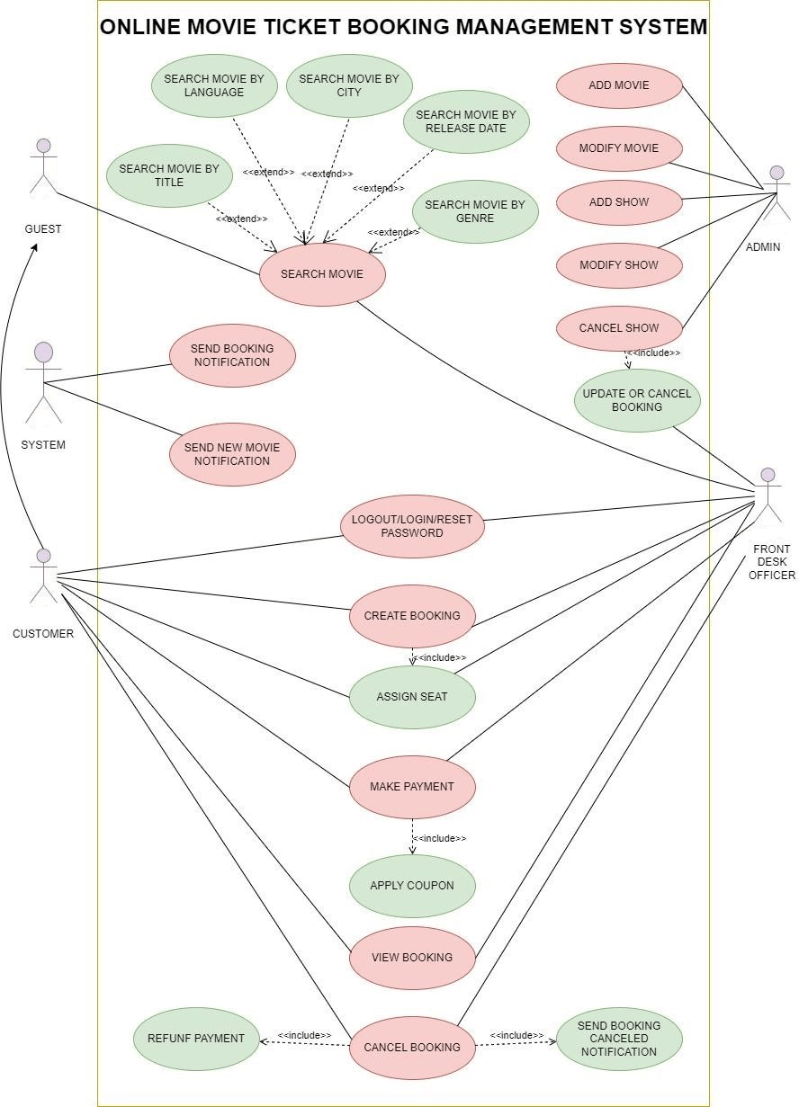 Fig 3.2: Use case Diagram

**3.7 BUSINESS USE CASE DESCRIPTION**

1. LOGIN /LOGOUT

Table 3.2: Use case scenario for LOGIN

|  |
| --- |
| USECASE DESCRIPTION |
| LOGIN/LOGOUT |
| STEP BY STEP DESCRIPTION |
| 1. First, open the login page of the system. 2. Enter the credential that is username and password. 3. Click on login. 4. Click on the logout button to logout of the online movie ticket booking system. |

2. SEARCH MOVIE

Table 3.3: Use case scenario for SEARCH MOVIE

|  |
| --- |
| USECASE DESCRIPTION |
| SEARCH MOVIE |
| STEP BY STEP DESCRIPTION |
| 1. Click on the search movie. 2. Select the option with which you want to filter the movie name. 3. Click on Search. |

3.ADD MOVIE/SHOW

Table 3.4: Use case scenario for ADD MOVIE/SHOW

|  |
| --- |
| USECASE DESCRIPTION |
| ADD MOVIE/SHOW |
| STEP BY STEP DESCRIPTION |
| 1. Admin login into the system. 2. Navigate to add movie or shoe. 3. The system presents a form to the admin to input details of the movie/show, such as the title, language, genre, cast, crew, synopsis, duration, release date, and poster image. 4. The admin fills in the required details and uploads the poster image. 5. The admin reviews the details and confirms the addition of the new movie/show. 6. The system validates the details and adds the movie/show to the database. 7. The system sends a notification to the admin confirming the successful addition of the new movie/show. |

1. MODIFY MOVIE/SHOW

Table 3.5: Use case scenario for MODIFY MOVIE/SHOW

|  |
| --- |
| USECASE DESCRIPTION |
| MODIFY MOVIE/SHOW |
| STEP BY STEP DESCRIPTION |
| 1. Admin login into the system. 2. Navigate to modify movie or shoe. 3. The system presents a form to the admin to input details of the movie/show, such as the title, language, genre, cast, crew, synopsis, duration, release date, and poster image. 4. Admin select the movie that should be modified. 5. The admin reviews the modified details and confirms the changes. |

1. CANCEL MOVIE/SHOW

Table 3.6: Use case scenario for CANCEL MOVIE/SHOW

|  |
| --- |
| USECASE DESCRIPTION |
| CANCEL MOVIE/SHOW |
| STEP BY STEP DESCRIPTION |
| 1. Admin login into the system. 2. Navigate to cancel movie or shoe. 3. The system presents a form to the admin to input details of the movie/show, such as the title, language, genre, cast, crew, synopsis, duration, release date, and poster image. 4. Admin select the movie that should be cancelled. 5. The admin reviews the cancelled details and confirms the cancellation. |

6.CREATE BOOKING

Table 3.7: Use case scenario for CREATE BOOKING

|  |
| --- |
| USECASE DESCRIPTION |
| CREATE BOOKING |
| STEP BY STEP DESCRIPTION |
| 1. The user navigates to the booking page for the selected movie/show. 2. The system presents a form to the user to input the booking details, such as the number of tickets, seat selection, and payment information. 3. The user fills in the required details and selects the seats for the booking. |

7. MAKE PAYMENT

Table 3.8: Use case scenario for MAKE PAYMENT

|  |
| --- |
| USECASE DESCRIPTION |
| MAKE PAYMENT |
| STEP BY STEP DESCRIPTION |
| 1. Apply coupon if available. 2. The user navigates to the payment page for the booking. 3. The system presents a payment form to the user, which includes the payment details such as payment method, payment amount, and billing information. 4. The user fills in the required payment details and confirms the payment. 5. The system sends the payment information to the payment gateway for processing. 6. The payment gateway authorizes the payment and sends a confirmation to the system. 7. The system validates the payment and updates the booking status. 8. The system sends a confirmation of the payment to the user and updates the theatre staff about the payment. |

8. VIEW BOOKING

Table 3.9: Use case scenario for VIEW BOOKING

|  |
| --- |
| USECASE DESCRIPTION |
| VIEW BOOKING |
| STEP BY STEP DESCRIPTION |
| 1. The user logs in to their account in the online movie ticket booking system. 2. The system presents the user's account dashboard, which includes a list of their bookings. 3. The user selects the booking they want to view. 4. The system presents the booking details to the user, including the movie/show, showtime, seats, and payment details. 5. The user reviews the booking details and confirms the information is correct. |

1. CANCEL BOOKING

Table 3.10: Use case scenario for CANCEL BOOKING

|  |
| --- |
| USECASE DESCRIPTION |
| CANCEL BOOKING |
| STEP BY STEP DESCRIPTION |
| 1. The user logs in to their account in the online movie ticket booking system. 2. The system presents the user’s account dashboard, which includes a list of their bookings. 3. The user selects the booking they want to cancel. 4. The system presents the booking details to the user, including the movie/show, showtime, seats, and payment details. 5. The user confirms that they want to cancel the booking. 6. The system cancels the booking and updates the booking status. 7. The system sends a cancellation confirmation to the user and updates the theatre staff about the cancellation. |

1. SEND NOTIFICATION

Table 3.11: Use case scenario for SEND NOTIFICATION

|  |
| --- |
| USECASE DESCRIPTION |
| SEND NOTIFICATION |
| STEP BY STEP DESCRIPTION |
| 1. The system determines that a notification needs to be sent, such as a Confirmation of a booking or cancellation, or a reminder of a upcoming show. 2. The system retrieves the user’s or theatre staff’s contact information, such as email address or phone number. 3. The system generates a notification message, including the relevant information, such as booking details or showtime reminders. 4. The system sends the notification message to the user or theatre staff through the appropriate communication channel, such as email or SMS. |

1. CHANGE LANGUAGE

Table 3.12: Use case scenario for CHANGE LANGUAGE

|  |
| --- |
| USECASE DESCRIPTION |
| CHANGE LANGUAGE |
| STEP BY STEP DESCRIPTION |
| 1. The user accesses the language settings in the online movie ticket booking system. 2. The system presents a list of available languages to the user. 3. The user selects the desired language from the list. 4. The system updates the language settings and presents the user interface in the selected language. 5. The user reviews the user interface to confirm that the language has been changed |

1. REGISTER

Table 3.13: Use case scenario for REGISTER

|  |
| --- |
| USECASE DESCRIPTION |
| REGISTER |
| STEP BY STEP DESCRIPTION |
| 1. The user accesses the registration page in the online movie ticket booking system. 2. The system presents a registration form to the user, which includes fields for the user’s personal information, such as name, email address, and password. 3. The user fills out the registration form with their personal information and selects a username and password for their account. 4. The user submits the registration form to the system. 5. The system validates the user’s information and creates a new account with the user’s provided information. 6. The system presents a confirmation message to the user indicating that their account has been created. 7. The user logs in to their newly created account. |

* 1. **Glossary**

Table 3.14: Glossary for online movie ticket booking system

|  |  |  |
| --- | --- | --- |
| SNO | WORD | MEANING |
| 1 | User | An individual who browses movies, select seats, and purchase tickets. |
| 2 | Movie | A feature-length film that is currently showing or available for booking |
| 3 | Theatre | A physical location where movies are screened for audiences. |
| 4 | Showtime | A specific time at which a movie is scheduled to be screened at a particular theatre. |
| 5 | Seat | A physical space in a theatre where a user can sit and watch a movie. |
| 6 | Booking | The process of reserving one or more seats for a specific movie at a particular theatre and show time. |
| 7 | Payment | The process of exchanging money for a ticket or seat reservation on the online movie ticket booking system. |
| 8 | Confirmation | A message or notification that the user receives after completing the booking process and making a payment. |
| 9 | Cancellation | The process of cancelling a seat reservation or ticket on the online movie ticket booking system. |
| 10 | Refund | The process of returning money to the user's account after cancelling a seat reservation or ticket. |
| 11 | Account | A user's personal space on the online movie ticket booking system, where they can manage their bookings, payment methods, and personal information. |
| 12 | Notification | A message or alert that the user receives from the online movie ticket booking system regarding their booking status, payment status, or other updates. |
| 13 | Language | The specific language in which the user interface of the online movie ticket booking system is displayed. |

**CHAPTER 04**

**ANALYSIS PHASE**

**4.1 Analysis & Refinement of problem statement**

**Analysis**

We cannot remove the online charges completely but we can reduce the percentage of the online charges for booking. We need to had more security while transferring of data like OTP. We need to keep an eye on the glitches, So Refined problem statement:

The system must have a simple and intuitive interface that allows users to quickly find and purchase tickets for the movies of their choice. In addition to providing a secure and reliable platform for purchasing movie tickets, the online movie ticket booking system must also provide an administration panel that allows authorized personnel to manage the system and monitor transactions. The system must have a simple and intuitive interface that allows users to quickly find and purchase tickets for the movies of their choice.

People love to get some cashback. We can give more cashback than the existing system. We can also give some special coupon for the regular customer which most of the existing system fail to give. Most of the system does not have real time booking. That means some system takes the customer to payment process then the booking gets failed. In such cases payment only may be carried out without seat booking. So, we need real time booking. Some system provides only limited seat booking. These are the drawbacks of existing system.

We should enable cancel booking option. So, that customer will get their refund. We have a challenge to handle the multiple booking at the same time. Accurate information should be passed to the customer. User interface should be easy and quickly accessible.

**4.2 ANALYSIS & REFINEMENT OF HARDWARE & SOFTWARE REQUIREMENTS**

**4.2.1 HARDWARE**

* Computer systems (desktops, laptops) with a minimum of 4GB of RAM and a fast processor.
* Database servers (such as MySQL, Oracle, etc.) to store user, theatre, and movie information.
* A minimum storage device is required to save coding, testing reports etc. The storage can be even any kind of hard disks.
* Printer: A thermal printer for printing tickets.

**4.2.2 SOFTWARE**

Security is much need for any kind of application. So, we require some protocols for secure transmission of data from user to system.

* Operating system (such as Windows, Linux, IOS etc.)
* Payment Gateway Integration: PayPal, Stripe, Authorize.net, Skrill
* Database management software (such as MySQL, Oracle, etc.)
* Secure communication protocols (such as SSL, TLS) to protect sensitive information (like password, OTP) during transmission.
* Front-End Development: HTML, CSS, JavaScript, React, AngularJS, Vue.js
* Software development tools and platforms (such as Java, .NET, etc.) to develop the application.
* Wireless connectivity is much need requirement.

* 1. **REFINED USE CASE DIAGRAM**

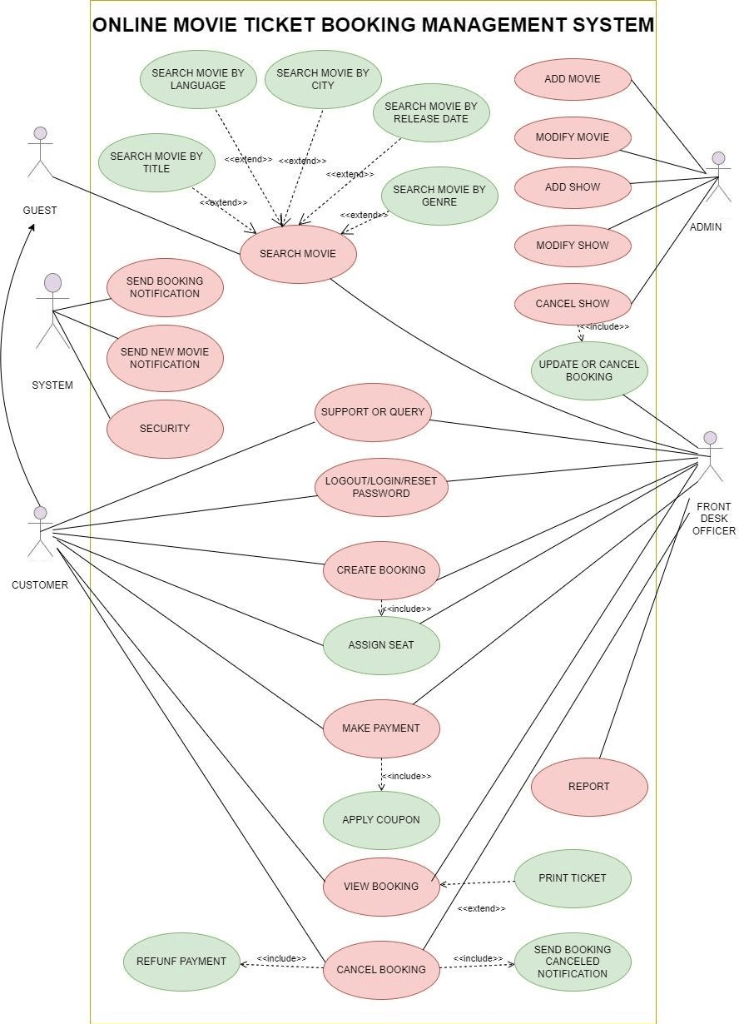

Fig 4.1: Refined Use case Diagram

1. REGISTER

Table 4.1: Refined Use case scenario for REGISTER

|  |
| --- |
| USECASE DESCRIPTION |
| REGISTER |
| STEP BY STEP DESCRIPTION |
| NORMAL:   1. The user accesses the registration page in the online movie ticket booking system. 2. The system presents a registration form to the user, which includes fields for the user's personal information, such as name, email address, and password. 3. The user fills out the registration form with their personal information and selects a username and password for their account. 4. The user submits the registration form to the system. 5. The system validates the user's information and creates a new account with the user's provided information. 6. The system presents a confirmation message to the user indicating that their account has been created. 7. The user logs in to their newly created account. |
| EXCEPTION:   1. If the user provides invalid or incomplete information, the system displays an error message indicating the fields that need to be corrected. The user corrects the fields and submits the form again. 2. If the email address is already associated with an existing account, the system displays an error message asking the user to choose a different email address. The user chooses a different email address and resubmits the form. 3. If the username is already taken by another user, the system displays an error message asking the user to choose a different username. The user chooses a different username and resubmits the form. |
| EXTENDED:   1. The user accesses the registration page in the online movie ticket booking system. 2. The system presents a registration form to the user, which includes fields for the user's personal information, such as name, email address, and password. 3. The user fills out the registration form with their personal information and selects a username and password for their account. 4. The user submits the registration form to the system. 5. The system validates the user's information and creates a new account with the user's provided information. 6. The system presents a confirmation message to the user indicating that their account has been created. 7. The user logs in to their newly created account. 8. After the user has successfully registered, the system sends a confirmation email to the user's email address. 9. The user receives the email and confirms their account by clicking on the provided link. 10. The system verifies the confirmation and marks the user's account as confirmed. |

2. LOGIN /LOGOUT

Table 4.2: Refined Use case scenario for LOGIN

|  |
| --- |
| USECASE DESCRIPTION |
| LOGIN/LOGOUT |
| STEP BY STEP DESCRIPTION |
| NORMAL:   1. First, open the login page of the system. 2. Enter the credential that is username and password. 3. Click on login. 4. Click on the logout button to logout of the online movie ticket booking system. |
| EXCEPTION:   1. If the user enters invalid login credentials, the system displays an error message asking the user to re-enter their credentials. 2. The user corrects their credentials and resubmits the form. |
| EXTENDED:   1. First, open the login page of the system. 2. Enter the credential that is username and password. 3. Click on login. 4. Click on the logout button to logout of the online movie ticket booking system. 5. Reset the password in case user forgot the password. |

1. SEARCH MOVIE

Table 4.3: Refined Use case scenario for SEARCH MOVIE

|  |
| --- |
| USECASE DESCRIPTION |
| SEARCH MOVIE |
| STEP BY STEP DESCRIPTION |
| NORMAL:   1. Click on the search movie. 2. Select the option with which you want to filter the movie name. 3. Click on Search. |
| EXCEPTION:   * 1. If there are no movies that match the search criteria, the system displays a message to the user indicating that there are no results for their search.   2. The user can modify their search criteria and resubmit the form. |
| EXTENDED:   1. The user navigates to the search page and selects the “Search Movie” option. 2. The system presents a search form to the user with fields for title, genre, rating, and release year. 3. The user enters their desired search criteria and submits the form. 4. The system retrieves a list of movies that match the search criteria and displays them to the user. 5. The user can browse through the list of movies and select a specific movie for more information or to purchase tickets. 6. The user selects a movie from the search results. 7. The system displays more information about the movie, including its synopsis, cast, and crew. 8. The user can read the information and decide whether to purchase tickets for the movie. 9. If the user decides to purchase tickets, they select the number of tickets and the showtime for the movie. 10. The system adds the tickets to the user’s cart and prompts them to checkout. 11. The user selects the “Checkout” option and proceeds to the payment page. 12. The user enters their payment information and submits the payment. 13. The system validates the payment and sends a confirmation email to the user. |

4.ADD MOVIE/SHOW

Table 4.4: Refined Use case scenario for ADD MOVIE/SHOW

|  |
| --- |
| USECASE DESCRIPTION |
| ADD MOVIE/SHOW |
| STEP BY STEP DESCRIPTION |
| NORMAL:   1. Admin login into the system. 2. Navigate to add movie or shoe. 3. The system presents a form to the admin to input details of the movie/show, such as the title, language, genre, cast, crew, synopsis, duration, release date, and poster image. 4. The admin fills in the required details and uploads the poster image. 5. The admin reviews the details and confirms the addition of the new movie/show. 6. The system validates the details and adds the movie/show to the database. 7. The system sends a notification to the admin confirming the successful addition of the new movie/show. |
| EXCEPTION:  1.If the input is invalid or incomplete, the system displays an error message to the admin indicating which fields need to be corrected or completed.  2. The admin corrects the input and resubmits the form. |
| EXTENDED:  1. The admin navigates to the “Add Movie/Show” page and selects the “Add Movie/Show” option.  2. The system presents a form to the admin with fields for the movie/show title, genre, rating, release year, duration, showtimes, and theatre.  3. The admin enters the details for the new movie/show and submits the form.  4. The system validates the input and adds the new movie/show to the system’s database.  5. The system sends a notification to the admin confirming that the movie/show has been successfully added.  6. After adding the movie/show, the system prompts the admin to upload a poster and trailer for the movie/show.  7. The admin uploads the poster and trailer using the provided upload functionality.  8. The system validates the poster and trailer files and adds them to the movie/show’s details in the system’s database.  9. The system sends a notification to the admin confirming that the movie/show has been successfully added with the poster and trailer. |

5.MODIFY MOVIE/SHOW

Table 4.5: Refined Use case scenario for MODIFY MOVIE/SHOW

|  |
| --- |
| USECASE DESCRIPTION |
| MODIFY MOVIE/SHOW |
| STEP BY STEP DESCRIPTION |
| NORMAL:   1. Admin login into the system. 2. Navigate to modify movie or shoe. 3. The system presents a form to the admin to input details of the movie/show, such as the title, language, genre, cast, crew, synopsis, duration, release date, and poster image. 4. Admin select the movie that should be modified. 5. The admin reviews the modified details and confirms the changes. |
| EXCEPTION:  If the input is invalid or incomplete, the system displays an error message to the admin indicating which fields need to be corrected or completed. The admin corrects the input and resubmits the form. |
| EXTENDED:   1. The admin navigates to the “Modify Movie/Show” page and selects the “Add Movie/Show” option. 2. The system presents a form to the admin with fields for the movie/show title, genre, rating, release year, duration, showtimes, and theatre. 3. The admin edits of the details movie/show and submits the form. 4. The system validates the input and adds the new updates movie/show to the system’s database. 5. The system sends a notification to the admin confirming that the movie/show has been successfully added. 6. After updating the movie/show, the system prompts the admin to upload a poster and trailer for the movie/show. 7. The admin uploads the poster and trailer using the provided upload functionality. 8. The system validates the poster and trailer files and adds them to the movie/show’s details in the system’s database. 9. The system sends a notification to the admin confirming that the movie/show has been successfully modified with the poster and trailer. |

6.CANCEL MOVIE/SHOW

Table 4.6: Refined Use case scenario for CANCEL MOVIE/SHOW

|  |
| --- |
| USECASE DESCRIPTION |
| CANCEL MOVIE/SHOW |
| STEP BY STEP DESCRIPTION |
| NORMAL:   * 1. Admin login into the system.   2. Navigate to cancel movie or shoe.   3. The system presents a form to the admin to input details of the movie/show, such as the title, language, genre, cast, crew, synopsis, duration, release date, and poster image.   4. Admin select the movie that should be cancelled.   5. The admin reviews the cancelled details and confirms the cancellation. |
| EXCEPTION:  If the admin decides not to cancel the movie/show, they can cancel the operation at this point and return to the previous page. |
| EXTENDED:   1. The admin navigates to the “Cancel Movie/Show” page and selects the “Cancel Movie/Show” option. 2. The system presents a list of movies/shows that are currently scheduled. 3. The admin selects the movie/show that they want to cancel from the list. 4. The system prompts the admin to confirm the cancellation. 5. The admin confirms the cancellation. 6. The system updates the movie/show’s status in the system’s database to “cancelled.” 7. The system sends a notification to all users who have booked tickets for the cancelled movie/show, informing them of the cancellation and providing options for a refund or a transfer to another movie/show. 8. If the cancelled movie/show was a part of a combo offer, the system automatically removes the cancelled movie/show from the combo offer and recalculates the price of the combo offer. 9. The system updates the combo offer’s details in the system’s database and sends a notification to all users who have booked tickets for the combo offer, informing them of the changes in the combo offer’s price and the movies/shows included in the offer. 10. If any user had booked a ticket for the cancelled movie/show as a part of a combo offer, the system automatically refunds the price difference to the user’s account or offers them a transfer to another movie/show included in the combo offer. 11. If the cancelled movie/show was part of a “season ticket” package, the system automatically removes the movie/show from the package and recalculates the price of the package. 12. The system updates the package’s details in the system’s database and sends a notification to all users who have purchased the package, informing them of the changes in the package’s price and the movies/shows included in the package. | |

7.CREATE BOOKING

Table 4.7: Refined Use case scenario for CREATE BOOKING

|  |
| --- |
| USECASE DESCRIPTION |
| CREATE BOOKING |
| STEP BY STEP DESCRIPTION |
| NORMAL:   1. The user navigates to the booking page for the selected movie/show. 2. The system presents a form to the user to input the booking details, such as the number of tickets, seat selection, and payment information. 3. The user fills in the required details and selects the seats for the booking. |
| EXCEPTION:   1. If there are no available seats for the selected movie/show, the system displays an error message and prompts the customer to select another movie/show. 2. If the payment method is invalid or payment fails, the system displays an error message and prompts the customer to select another payment method or update their payment details. 3. If the selected seats are no longer available (e.g., another customer booked the same seats), the system displays an error message and prompts the customer to select another set of seats or choose another movie/show. |
| EXTENDED:   1. The user navigates to the booking page for the selected movie/show. 2. The system presents a form to the user to input the booking details, such as the number of tickets, seat selection, and payment information. 3. The user fills in the required details and selects the seats for the booking. 4. The customer selects any desired add-ons or premium options and the system recalculates the total price. 5. The system confirms the payment for the add-ons and/or premium options and updates the booking details in the system's database. |

8.MAKE PAYMENT

Table 4.8: Refined Use case scenario for MAKE PAYMENT

|  |
| --- |
| USECASE DESCRIPTION |
| MAKE PAYMENT |
| STEP BY STEP DESCRIPTION |
| NORMAL:   1. Apply coupon if available. The user navigates to the payment page for the booking. 2. The system presents a payment form to the user, which includes the payment details such as payment method, payment amount, and billing information. 3. The user fills in the required payment details and confirms the payment. 4. The system sends the payment information to the payment gateway for processing. 5. The payment gateway authorizes the payment and sends a confirmation to the system. 6. The system validates the payment and updates the booking status. 7. The system sends a confirmation of the payment to the user and updates the theatre staff about the payment. |
| EXCEPTION:   1. An exceptional use case is a scenario where the payment transaction fails due to a technical error or a communication breakdown with the payment gateway. 2. The user may have already selected and reserved their desired movie seats, but the payment fails before the transaction can be completed. 3. The payment module should have a built-in mechanism to detect failed transactions and trigger a rollback process to undo the reservation of the movie seats. 4. The system should notify the user of the failed transaction and provide clear instructions on how to retry the payment process. 5. The payment module should have a robust error handling mechanism to detect and log any technical errors that occur during the payment process. 6. The system administrators should be able to investigate and resolve any technical issues that may cause payment failures and prevent them from reoccurring in the future. |
| EXTENDED:   1. The user selects a movie and a showtime and chooses their desired seats. 2. The system verifies the availability of the selected seats and reserves them for the user. 3. The user proceeds to the payment page to complete the transaction. 4. The payment module securely collects the user's payment details and sends them to the payment gateway for processing. 5. The payment gateway validates the payment details and communicates with the user's bank to authorize the transaction. 6. If the transaction is successful, the payment gateway sends a confirmation message to the payment module, which then updates the system's database with the payment information. 7. The system confirms the booking and generates a ticket for the user. 8. The user receives the ticket via email or on the booking confirmation page and can proceed to the cinema to watch the movie. 9. In the event of a payment transaction failure, the payment module detects the failure and triggers a rollback process to undo the reservation of the movie seats. 10. The system notifies the user of the failed transaction and provides clear instructions on how to retry the payment process. 11. The payment module logs the error and provides a detailed error message to the system administrators for troubleshooting and resolution. 12. The system administrators investigate and resolve the technical issues causing payment failures to prevent them from reoccurring in the future. 13. The payment module also monitors payment transaction activities and sends alerts to the system administrators for any suspicious or fraudulent activities. 14. The payment module uses industry-standard security protocols and encryption methods to ensure the safety and privacy of the user's payment details. |

9.VIEW BOOKING

Table 4.9: Refined Use case scenario for VIEW BOOKING

|  |
| --- |
| USECASE DESCRIPTION |
| VIEW BOOKING |
| STEP BY STEP DESCRIPTION |
| NORMAL:   1. The user logs in to their account in the online movie ticket booking system. 2. The system presents the user’s account dashboard, which includes a list of their bookings. 3. The user selects the booking they want to view. 4. The system presents the booking details to the user, including the movie/show, showtime, seats, and payment details. 5. The user reviews the booking details and confirms the information is correct. |
| EXCEPTION:   1. An exceptional use case is a scenario where the user is unable to view their booking details after completing a booking transaction. 2. The user may have received a confirmation message or email indicating that their booking was successful, but the system fails to display the booking details when the user tries to view them. 3. The system should be able to handle such an exceptional use case and provide clear error messages to the user indicating the reason for the failure. 4. Possible reasons for the failure may include technical errors, communication breakdowns, or database errors. 5. The system should have a built-in mechanism to detect such errors and trigger an error handling process to resolve them. 6. The error handling process may involve logging the error details and notifying the system administrators to investigate and resolve the issue. 7. The system should also provide a fallback option for the user to view their booking details through alternative means, such as contacting customer support or visiting the cinema’s box office. 8. The system should prioritize the user’s experience and aim to resolve the issue promptly to minimize any inconvenience caused to the user. 9. The view booking module should also have a user-friendly interface that allows the user to easily view and manage their booking details, including the movie title, showtime, seat numbers, and transaction details. 10. The system should also allow the user to modify or cancel their booking if they need to make any changes. 11. The system should maintain the security and privacy of the user’s booking details by using industry-standard security protocols and encryption methods. 12. The system should also provide clear instructions to the user on how to safeguard their booking details and prevent unauthorized access to them. |
| EXTENDED:   1. The user logs in to their account on the movie ticket booking system and navigates to the view booking module. 2. The system displays a list of the user’s current and past bookings, including the movie title, showtime, seat numbers, and transaction details. 3. The user can select a booking to view more details, such as the cinema location, screen number, and ticket price. 4. The user can also modify or cancel the booking if they need to make any changes or cancel their reservation. 5. The system updates the booking details in real-time and sends confirmation messages to the user via email or on the booking confirmation page. 6. In the event of a technical error or communication breakdown, the system provides clear error messages to the user indicating the reason for the failure and possible solutions to resolve the issue. 7. The system also logs the error details and notifies the system administrators to investigate and resolve the issue promptly. 8. The view booking module should also have a user-friendly interface that allows the user to easily navigate and filter their booking history by movie title, cinema location, showtime, and transaction details. 9. The system should also provide the user with a history of their past bookings, including the movie title, showtime, seat numbers, and transaction details. 10. The system should also have a built-in mechanism to detect and prevent any fraudulent activities, such as unauthorized access to the user’s booking details or changes to the booking information without the user’s consent. 11. The system should also maintain the security and privacy of the user’s booking details by using industry-standard security protocols and encryption methods. 12. The system should also provide clear instructions to the user on how to safeguard their booking details and prevent unauthorized access to them, such as using strong passwords and regularly updating their account information. |

10.CANCEL BOOKING

Table 4.10: Refined Use case scenario for CANCEL BOOKING

|  |
| --- |
| USECASE DESCRIPTION |
| CANCEL BOOKING |
| STEP BY STEP DESCRIPTION |
| NORMAL:   1. The user logs in to their account in the online movie ticket booking system. 2. The system presents the user’s account dashboard, which includes a list of their bookings. 3. The user selects the booking they want to cancel. 4. The system presents the booking details to the user, including the movie/show, showtime, seats, and payment details. 5. The user confirms that they want to cancel the booking. 6. The system cancels the booking and updates the booking status. 7. The system sends a cancellation confirmation to the user and updates the theatre staff about the cancellation. |
| EXCEPTION:   1. An exceptional use case is a scenario where the user is unable to cancel their booking due to a technical error or communication breakdown in the system. 2. The user may have attempted to cancel their booking within the specified cancellation window, but the system fails to process their request. 3. The system should be able to handle such an exceptional use case and provide clear error messages to the user indicating the reason for the failure. 4. Possible reasons for the failure may include technical errors, communication breakdowns, or database errors. 5. The system should have a built-in mechanism to detect such errors and trigger an error handling process to resolve them. 6. The error handling process may involve logging the error details and notifying the system administrators to investigate and resolve the issue. 7. The system should also provide a fallback option for the user to cancel their booking through alternative means, such as contacting customer support or visiting the cinema’s box office. 8. The system should prioritize the user’s experience and aim to resolve the issue promptly to minimize any inconvenience caused to the user. 9. The cancel booking module should also have a user-friendly interface that allows the user to easily cancel their booking, including the movie title, showtime, seat numbers, and transaction details. 10. The system should update the booking details in real-time and send confirmation messages to the user via email or on the booking cancellation page. 11. The system should also have a built-in mechanism to detect and prevent any fraudulent activities, such as unauthorized cancellation of the user’s booking or changes to the booking information without the user’s consent. 12. The system should also maintain the security and privacy of the user’s booking details by using industry-standard security protocols and encryption methods. 13. The system should also provide clear instructions to the user on how to safeguard their booking details and prevent unauthorized access to them, such as using strong passwords and regularly updating their account information. |
| EXTENDED:   1. The user logs in to their account on the movie ticket booking system and navigates to the cancel booking module. 2. The system displays a list of the user’s current and upcoming bookings, including the movie title, showtime, seat numbers, and transaction details. 3. The user can select a booking to cancel, and the system prompts the user to confirm their cancellation. 4. The system verifies that the user is Cancelling the booking within the specified cancellation window and confirms the cancellation with the user. 5. The system updates the booking details in real-time and sends confirmation messages to the user via email or on the booking cancellation page. 6. If the user cancels their booking outside of the specified cancellation window, the system should inform the user that cancellation is not possible and suggest alternative options, such as rescheduling or exchanging the tickets. 7. In the event of a technical error or communication breakdown, the system provides clear error messages to the user indicating the reason for the failure and possible solutions to resolve the issue. 8. The system also logs the error details and notifies the system administrators to investigate and resolve the issue promptly. 9. The cancel booking module should also have a user-friendly interface that allows the user to easily navigate and filter their booking history by movie title, cinema location, showtime, and transaction details. 10. The system should also provide the user with a history of their past bookings, including the movie title, showtime, seat numbers, and transaction details. 11. The system should also have a built-in mechanism to detect and prevent any fraudulent activities, such as unauthorized cancellation of the user’s booking or changes to the booking information without the user’s consent. 12. The system should also maintain the security and privacy of the user’s booking details by using industry-standard security protocols and encryption methods. 13. The system should also provide clear instructions to the user on how to safeguard their booking details and prevent unauthorized access to them, such as using strong passwords and regularly updating their account information. |

11. SEND NOTIFICATION

Table 4.11: Refined Use case scenario for SEND NOTIFICATION

|  |
| --- |
| USECASE DESCRIPTION |
| SEND NOTIFICATION |
| STEP BY STEP DESCRIPTION |
| NORMAL:   1. The system determines that a notification needs to be sent, such as a Confirmation of a booking or cancellation, or a reminder of an upcoming show. 2. The system retrieves the user’s or theatre staff’s contact information, such as email address or phone number. 3. The system generates a notification message, including the relevant information, such as booking details or showtime reminders. 4. The system sends the notification message to the user or theatre staff through the appropriate communication channel, such as email or SMS. |
| EXCEPTION:   1. The send notification module is designed to send timely and relevant notifications to users about their booking status, showtimes, cancellations, and other relevant information related to their movie tickets. 2. In exceptional cases, the system may encounter errors while sending notifications to users, such as network connectivity issues, server downtime, or system failures. 3. If the system is unable to send notifications to users, it should maintain a log of the failed notifications, including the user’s details, the type of notification, and the reason for the failure. 4. The system should have a built-in mechanism to automatically retry sending failed notifications to users after a certain period, such as 24 hours, to ensure that users receive timely updates about their bookings. 5. In cases where the system is unable to send notifications to users even after multiple attempts, the system should alert the system administrators and the support team to investigate and resolve the issue promptly. 6. If a user’s contact details, such as their email address or phone number, are incorrect or outdated, the system should detect and inform the user about the issue and prompt them to update their contact information in their account settings. 7. In exceptional cases, the system may encounter situations where it is unable to send notifications to users due to external factors, such as natural disasters, power outages, or internet shutdowns. In such cases, the system should alert the users about the situation and provide them with alternative options, such as rescheduling their bookings or issuing refunds. 8. The system should also have a built-in mechanism to detect and prevent any fraudulent activities related to notifications, such as sending fake notifications or phishing attempts to extract sensitive user information. The system should use industry-standard security protocols and encryption methods to maintain the security and privacy of user data. 9. The send notification module should also have a user-friendly interface that allows users to customize their notification preferences and choose the type and frequency of notifications they receive. The system should also allow users to opt-out of certain notifications if they find them irrelevant or too frequent. 10. The system should also have a built-in mechanism to provide users with feedback about the notifications they receive and allow them to rate the usefulness and relevance of the notifications. The system should use this feedback to improve the quality and effectiveness of its notifications in the future. |
| EXTENDED:   1. The send notification module is an essential component of an online movie ticket booking system that is responsible for sending timely and relevant notifications to users about their booking status, showtimes, cancellations, and other important information related to their movie tickets. 2. The system should allow users to choose the preferred mode of notification, such as email, SMS, or push notifications, based on their convenience and availability. The system should also provide users with the option to add multiple contact details, such as email address, phone number, and social media handles, to ensure that they receive notifications even if one contact detail is unavailable. 3. The send notification module should also have a robust and reliable architecture that ensures the seamless delivery of notifications to users. The system should use a reliable and secure communication channel, such as SMTP or API-based services, to send notifications to users in real-time. The system should also have a backup mechanism, such as a secondary email address or phone number, to ensure that users receive notifications even if the primary contact detail is unavailable. 4. The system should allow users to customize the frequency and type of notifications they receive based on their preferences. For example, users should be able to choose whether they want to receive notifications for upcoming movies, showtimes, cancellations, or other relevant information related to their bookings. The system should also provide users with the option to set the time and frequency of notifications, such as daily, weekly, or monthly updates, based on their availability and schedule. 5. In exceptional cases, the system may encounter errors or issues while sending notifications to users, such as network connectivity issues, server downtime, or system failures. In such cases, the system should have a built-in mechanism to detect and resolve the issues promptly. The system should also maintain a log of the failed notifications, including the user’s details, the type of notification, and the reason for the failure, to ensure that users receive timely updates about their bookings. 6. If the system is unable to send notifications to users even after multiple attempts, the system should alert the system administrators and the support team to investigate and resolve the issue promptly. The system should also have a built-in mechanism to retry sending failed notifications after a certain period, such as 24 hours, to ensure that users receive timely updates about their bookings. 7. The system should also have a user-friendly interface that allows users to manage their notification preferences and update their contact details. The system should allow users to opt-out of certain notifications if they find them irrelevant or too frequent. The system should also have a feedback mechanism that allows users to rate the usefulness and relevance of the notifications they receive and provide suggestions for improvement. |

12. CHANGE LANGUAGE

Table 4.12: Refined Use case scenario for CHANGE LANGUAGE

|  |
| --- |
| USECASE DESCRIPTION |
| CHANGE LANGUAGE |
| STEP BY STEP DESCRIPTION |
| NORMAL:   1. The user accesses the language settings in the online movie ticket booking system. 2. The system presents a list of available languages to the user. 3. The user selects the desired language from the list. 4. The system updates the language settings and presents the user interface in the selected language. 5. The user reviews the user interface to confirm that the language has been changed |
| EXCEPTION:   1. The change language module is a critical component of an online movie ticket booking system that enables users to change the language of the user interface based on their preference or need. The system should provide users with a list of available languages, such as English, Spanish, French, German, and others, and allow them to select the preferred language from the list. 2. In exceptional cases, the system may encounter issues with the CHANGE LANGUAGE module, which may prevent users from changing the language of the user interface. For example: 3. Network issues: The system may experience network issues that prevent it from accessing the language files or communicating with the language server. As a result, the system may not be able to display the list of available languages, or users may not be able to select a language from the list. 4. Internal errors: The system may encounter internal errors while processing user requests to change the language, which may result in unexpected behaviour or errors. For example, the system may display an error message, freeze, or crash, or change the language to an unexpected language. 5. Incompatibility issues: The system may encounter incompatibility issues with the user's device or browser, which may prevent the system from displaying the user interface in the selected language. For example, the user's device may not support the font or encoding used by the selected language, or the browser may not support certain language features. 6. To handle these exceptional cases, the system should provide appropriate error messages or notifications to inform users of the issue and provide guidance on how to resolve the issue. For example, the system may display an error message that explains the issue and suggests that the user try again later, check their network connection, or use a different device or browser. The system should also log the error and provide debugging information to support teams for troubleshooting and resolving the issue. |
| EXTENDED:   1. The CHANGE LANGUAGE module is a critical component of an online movie ticket booking system that enables users to change the language of the user interface based on their preference or need. The system should provide users with a list of available languages, such as English, Spanish, French, German, and others, and allow them to select the preferred language from the list. 2. When a user selects a language from the list, the system should update the user interface to display all the text and labels in the selected language. The system should also store the user's language preference and use it as the default language for all subsequent sessions or visits. 3. In exceptional cases, the system may encounter issues with the CHANGE LANGUAGE module, which may prevent users from changing the language of the user interface. For example: 4. Network issues: The system may experience network issues that prevent it from accessing the language files or communicating with the language server. As a result, the system may not be able to display the list of available languages, or users may not be able to select a language from the list. To handle this, the system should display an appropriate error message or notification to inform users of the issue and suggest they try again later or check their network connection. 5. Internal errors: The system may encounter internal errors while processing user requests to change the language, which may result in unexpected behaviour or errors. For example, the system may display an error message, freeze, or crash, or change the language to an unexpected language. To handle this, the system should provide appropriate error messages or notifications to inform users of the issue and provide guidance on how to resolve the issue. The system should also log the error and provide debugging information to support teams for troubleshooting and resolving the issue. 6. Incompatibility issues: The system may encounter incompatibility issues with the user's device or browser, which may prevent the system from displaying the user interface in the selected language. For example, the user's device may not support the font or encoding used by the selected language, or the browser may not support certain language features. To handle this, the system should provide appropriate error messages or notifications to inform users of the issue and suggest they try using a different device or browser. The system should also provide guidance on how to configuration their device or browser to support the selected language. 7. In addition to the exceptional cases, the system should also handle other scenarios, such as: 8. Language availability: The system should ensure that all the available languages are up to date and accurately reflect the languages supported by the system. If a language is no longer supported or unavailable, the system should remove it from the list of available languages. 9. User experience: The system should provide a seamless and intuitive user experience when users change the language. For example, the system should update the user interface in real-time as users select different languages, without requiring users to refresh the page or restart their session. |

**4.4 5 STEP ANALYSIS**

**5 STEP PROBLEM ANALYSIS**

**STEP – 1: GAIN AGREEMENT ON THE PROBLEM DEFINITION**.

Table 4.13: Gain Agreement

|  |  |
| --- | --- |
| ELEMENT | DEFINITION |
| The Problem of ….                  Affects ….  And results in ….                    Benefits of the Solution | Experiencing difficulties while booking movie tickets online.  The system may be slow, not user-friendly, or there may be technical issues that prevent customers from completing the booking process.    Customers, Theatre owners, Producers.    The system may not be easily accessible for customers who are seeking information about movies, selecting theatre and show timings. This could result in poor user experience and decreased efficiency in the booking process.  The movie information may not be updated regularly leading to incorrect data and information being used during the booking process.    Improved User Experience.  Increased Efficiency.  Reduced Costs.  Increased Revenue.  Improved Data Tracking. |

## STEP-2: UNDERSTAND THE ROOT CAUSES

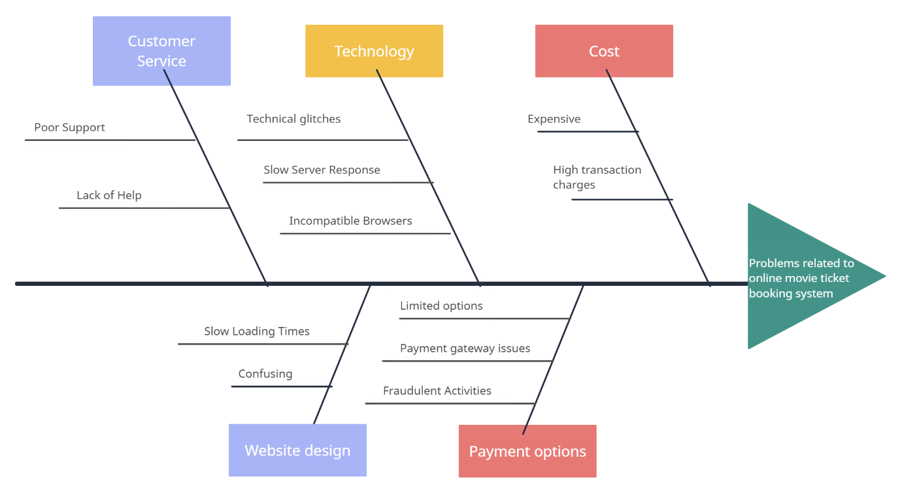

Fig 4.2: Fish bone diagram

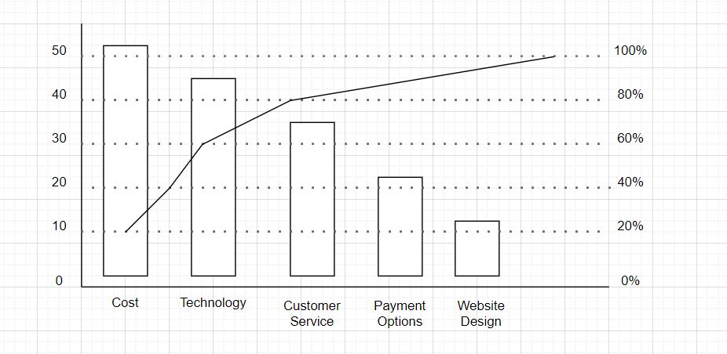

Fig 4.3: Pareto chart

**STEP-3: IDENTIFY THE STAKEHOLDERS AND USERS**

Table 4.14: Stakeholder and user

|  |  |
| --- | --- |
| USERS | OTHER STAKEHOLDERS |
| * Casual Moviegoers * Regular Moviegoers * Families * Group Bookers * Advance Bookers | * Movie theatres * Movie distributers * Online booking system providers * Payment gateway providers * Users * Regulators |

## STEP-4: DEFINE SOLUTION SYSTEM BOUNDARY

System Boundary defines the border between the solution and the real world that surrounds the solution.

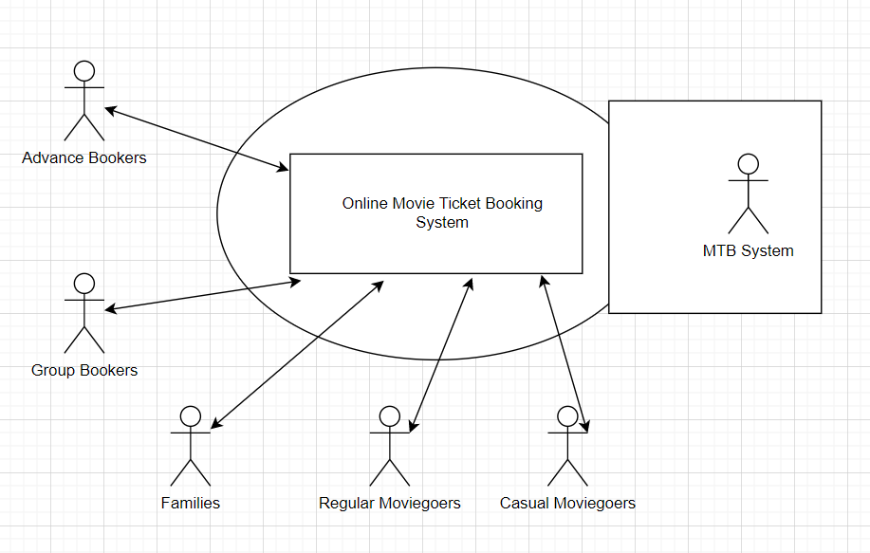Fig 4.4: System boundary

**STEP-5: IDENTIFY THE CONSTRAINTS TO BE IMPOSED ON THE SOLUTION**

Table 4.15: Constraints Imposed

|  |  |  |
| --- | --- | --- |
| SOURCE | CONSTRAINT | RATIONALE |
| OPERATIONS  SYSTEMS  EQUIPMENT BUDGET  PERSONNEL BUDGET  TECHNOLOGY MANDATE | An exact copy of processing the billing, and exact copy of invoiced data must remain on the legacy database for up to 1 year.    The application footprint on the server must be less than 20MB.    The system must be developed on existing server and host.    Staffing resources are fixed.      A new object-oriented methodology should be used. | The risk of data loss is too great.            We have limited server memory available.    We need to control cost and maintain existing systems.    The current budget calls for fixed operating costs.    We believe this technology will increase productivity and reliability of the software. |

* 1. **ANALYSIS & REFINEMENT OF HARDWARE & SOFTWARE REQUIREMENTS**

**4.4.1 FUNCTIONAL REQUIREMENT**

We can add print function requirement. This requirement allows the user to print their movie/show ticket before reaching to their booked theatre. We can add the support for the customer which will be under the front desk officer.

Front desk should have the report on the ticket sale, revenue etc. So monthly a report should be generated. This enhances the account details of the ticket sale.

1. User registration and login: Users should be able to create an account, log in, and manage their profile information.
2. Movie searching: The system should display a list of currently available movies (with the language that is released), their descriptions (this includes the genre, list of the case, etc.,), showtimes, and available seats.
3. Seat assignment: Users should be able to select their preferred seats and view a map of the theatre layout.
4. Payment processing: The system should support multiple payment methods and process payments securely.
5. Confirmation of ticket purchase: The system should send a confirmation of the ticket purchase to the user via email or SMS.
6. Ticket management: Users should be able to view, print or cancel their tickets.
7. Theatre management: The system should allow theatre managers to update movie listings, showtimes, and seating arrangements.
8. Offer: Any offer that is applied during the booking must affect the price of the ticket accordingly, coupons, referral codes are also included.
9. Report generation: The system should generate reports on ticket sales, revenue, and other relevant data.
10. Social sharing: The system should allow users to share their booking details on social media platforms to increase brand awareness and user engagement.
11. Multiple languages and currencies: The system should be able to support multiple languages and currencies to cater to a diverse user base.
12. Loyalty programs: The system should have provisions for loyalty programs to incentivize repeat bookings and increase customer retention.
13. Customer support: The system should provide a mechanism for customers to receive support and resolve any issues.

These are the ten compulsory functional requirements need to build the online movie ticket booking management system.

**4.4.2 NON-FUNCTIONAL REQUIREMENT**

1. User experience: The system should have a user-friendly interface and be easy to navigate.
2. Performance: The system should be fast and responsive, with minimal downtime.
3. Scalability: The system should be able to handle increasing numbers of users and transactions without degradation in performance.
4. Reliability: The system should be dependable, with minimal errors or crashes.
5. Compatibility: The system should be compatible with different devices and web browsers.
6. Accessibility: The system should be accessible to users with disabilities, including those using assistive technologies.
7. Data privacy: The system should protect user data and comply with relevant privacy regulations.

1. Compliance: The system should comply with relevant legal and regulatory requirements.
2. Integration: The system should integrate with existing systems, such as accounting and reporting systems.
3. Maintenance: The system should be maintainable, with clear documentation and easy-to use tools for making updates and improvements.
4. Security: The system should be secure, with proper measures in place to prevent unauthorized access, hacking, and data breaches.
5. Backups and Recovery: The system should have regular backups and a recovery plan in case of data loss or system failures.

**4.5 STORYBOARD**

**SCENE 1:**

A man named Monish walked into the hotel. He is free tomorrow. So, he decided to go to movie which was released yesterday. But he taught that there will be large queue for purchasing the ticket. He was afraid of the queue. Most of the people do not like to stand in the queue.

There is no assurance of the ticket while standing in that large queue.

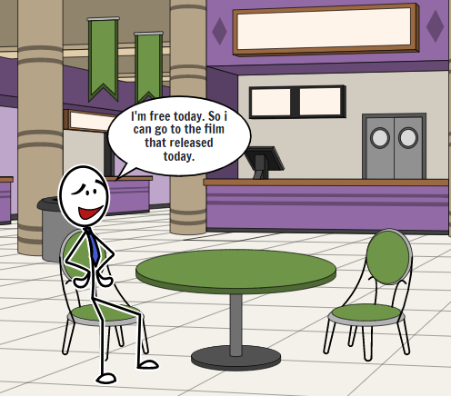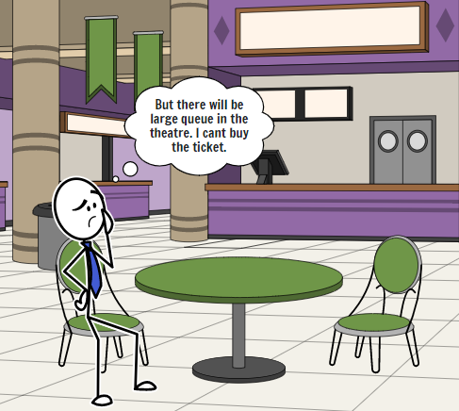

Fig 4.5: Storyboard 1

**SCENE 2:**

He remembered of the online movie ticket booking system which was told by his friend. He downloaded and opened the application. First, we need to register our account with our email id and password. Then we need to login to the application to book the mobile ticket.

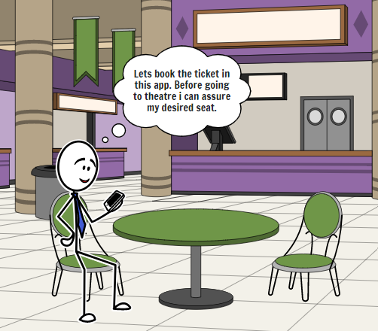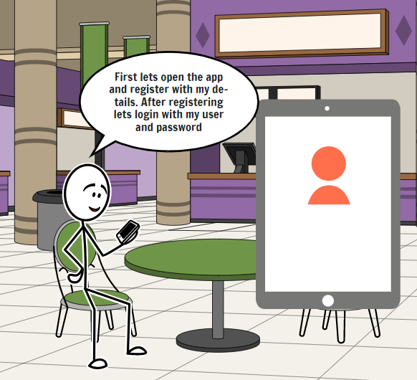

Fig 4.6: Storyboard 2

**SCENE 3:**

A user opens the online movie ticket booking system on their mobile device. They see a list of current movies with images, ratings, and descriptions. The user selects a movie they want to see and taps the "Showtimes" button. The system shows a list of available showtimes at nearby theatres. The user selects a showtime and the number of tickets they want to purchase. They are prompted to payment gateway.

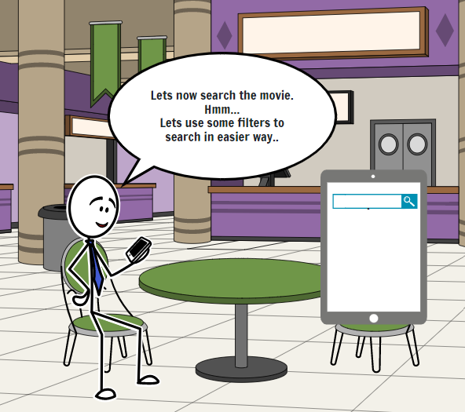 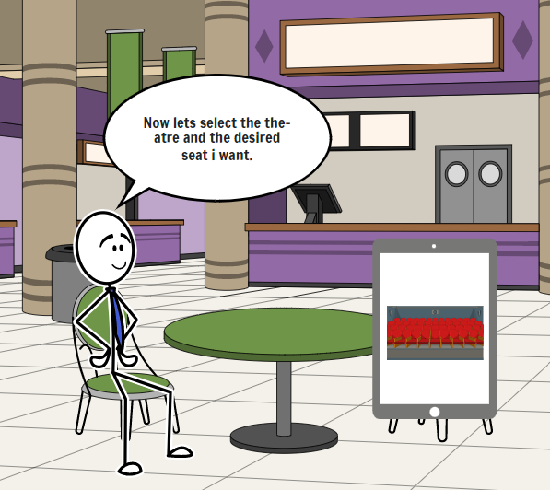

Fig 4.7: Storyboard 3

**SCENE 4:**

The user enters their payment information and taps "Confirm Order." The system shows a confirmation screen with the movie, theater, showtime, and ticket information. The user receives an email with the ticket information and a QR code to be scanned at the theater. Before payment monish added the procode for his first booking in the application.

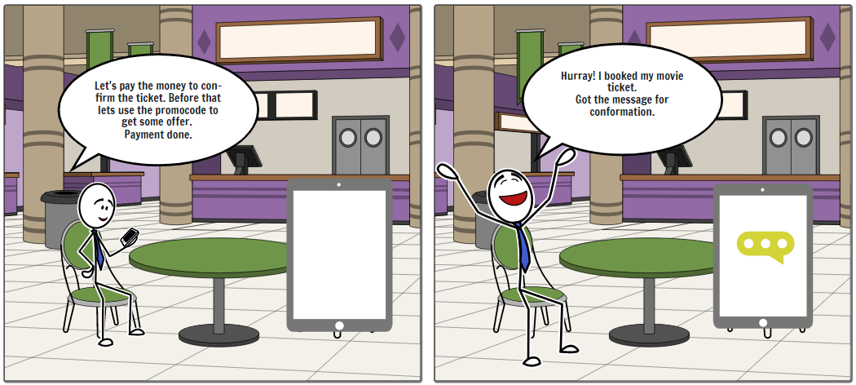

Fig 4.8: Storyboard 4

**SCENE 5:**

Monish can view the ticket he booked. It has a QR code which is required for the user to enter the theatre. If he wants to cancel the ticket, he can cancel it with full refund of the amount from the system/application. 100% refund is the main feature that every system should has for the user convenient.

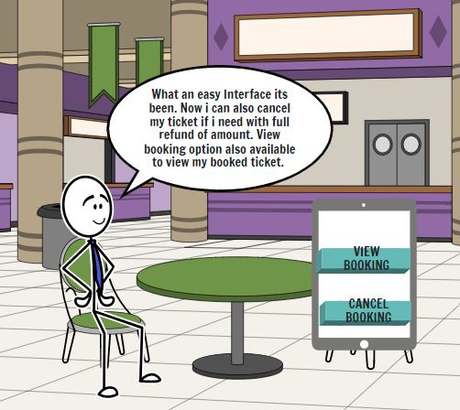 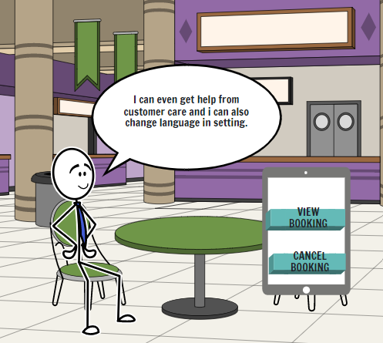

Fig 4.9: Storyboard 5

**SCENE 6:**

Select the "Add Show" option. Admin enters the movie details such as movie name, show timings, duration, language, and price. Admin selects the theater in which the movie will be screened. System verifies the details and saves the show in the database. System sends a confirmation message to the admin. Selects the "Modify Show" option. Admin can modify the show details such as movie name, show timings, duration, language, and price. System verifies the modified details and updates the show in the database. Selects the "Cancel Show" option. Admin selects the show to be canceled. System prompts for the reason for cancellation. System updates the show status to "Canceled" in the database. System sends a notification to the users who have booked tickets for the canceled show and refunds their payment.

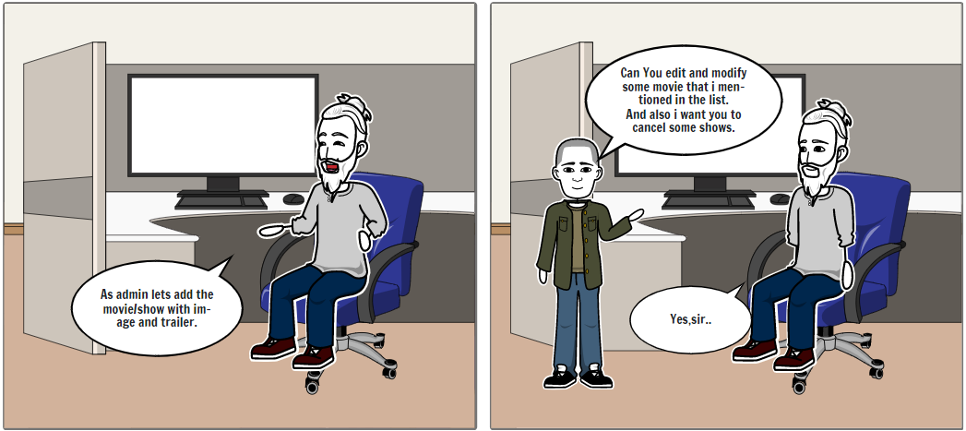

Fig 4.10: Storyboard 6

**SCENE 7:**

The user arrives at the theater and scans their QR code at the ticket counter. The system validates the code and prints the tickets. The user enjoys the movie with their friends, knowing that they have reserved their seats ahead of time with the online movie ticket booking system.

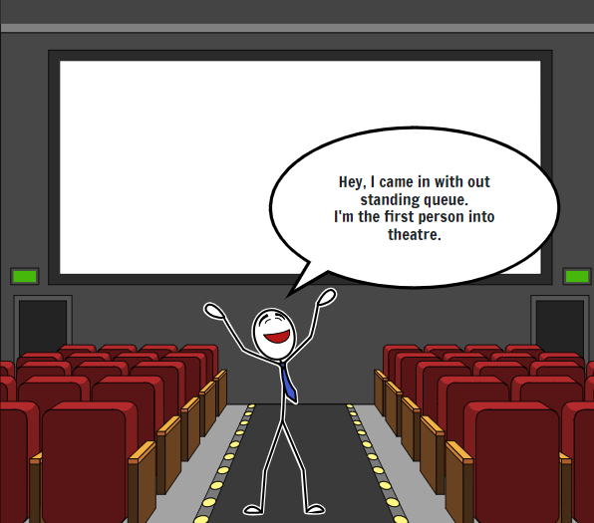

Fig 4.11: Storyboard 7

**CHAPTER 05**

**DESIGN PHASE**

**5.1 ARCHITECTURE OF THE ONLINE MOVIE TICKET BOOKING SYSTEM**

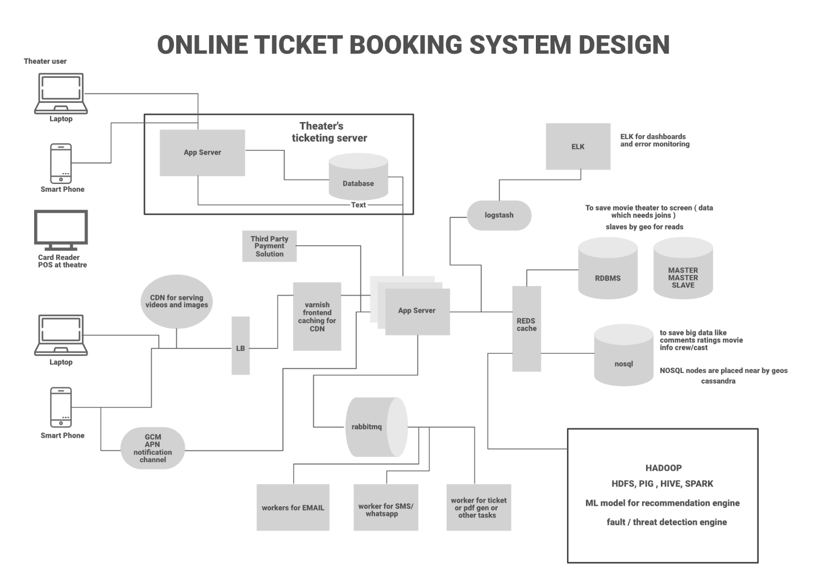

Fig 5.1: Architecture of the system

The architecture of an online movie ticket booking system typically consists of four main layers: the user interface layer, the application logic layer, the backend API layer, and the database layer. The user interface layer is responsible for providing a user-friendly interface for users to browse and book movie tickets. This layer typically consists of a web application that can be accessed using a web browser or mobile device. The user interface layer includes features like movie listings, showtimes, seat selection, payment options, and booking confirmations. The application logic layer is responsible for processing user requests and interacting with the backend API layer. This layer is typically implemented using a modern front-end framework like React, Angular, or Vue. The application logic layer includes features like user authentication, data validation, and business logic.

The backend API layer is responsible for processing requests from the application logic layer and interacting with the database layer. This layer typically consists of a RESTful API that provides endpoints for various features of the system, like booking tickets, updating seat availability, and generating invoices. The backend API layer is designed to be secure, scalable, and performant. The database layer is responsible for storing and retrieving data required for the application. This layer typically consists of a relational database like MySQL or PostgreSQL. The database layer includes tables for storing movie details, showtimes, seat availability, user information, booking details, and other related data.

In summary, the architecture of an online movie ticket booking system consists of a web-based user interface, an application logic layer, a backend API layer, and a database layer. This architecture is designed to be scalable, secure, and performant, and can handle many users browsing movies, booking tickets, and making payments at the same time.

**5.2 MODULES**

User Management Module:

This module is responsible for managing user accounts, authentication, and authorization. Users can create accounts, login, update their profile information, and view their booking history.

Movie Management Module:

This module is responsible for managing the movie database, including details about movies, showtimes, ratings, and reviews. Admin users can add new movies, update existing movies, and manage showtimes.

Seat Selection Module:

This module is responsible for allowing users to select their preferred seats for a given showtime. Users can select seats based on availability, price, and location.

Payment Module:

This module is responsible for processing payments for movie tickets. Users can pay for their tickets using various payment methods, including credit/debit cards, net banking, e-wallets, and other payment gateways.

Booking Confirmation Module:

This module is responsible for sending booking confirmations to users after they have successfully booked their tickets. Users receive a confirmation email or SMS with details about the movie, showtime, seats, and booking ID.

Customer Support Module:

This module is responsible for providing customer support to users in case of any issues or queries. Users can reach out to customer support via email, chat, or phone, and get their queries resolved in a timely manner.

Discount & Promotion Module:

This module is responsible for managing various discount and promotional offers for users. Admin users can create discount codes, offer cashback or discounts for certain payment methods, and provide other promotions to attract users.

Analytics & Reporting Module:

This module is responsible for generating various reports and analytics on the system's performance. Admin users can view reports on ticket sales, revenue, user activity, and other key metrics to make informed decisions.

Localization Module:

This module is responsible for providing support for multiple languages and currencies. Users can select their preferred language and currency, and the system will display information accordingly.

Social Media Integration Module:

This module is responsible for integrating social media platforms like Facebook, Twitter, and Instagram into the system. Users can share movie details, reviews, and other information with their friends and followers on social media.

SMS & Email Notification Module:

This module is responsible for sending notifications to users via SMS and email. Users receive notifications for booking confirmation, cancellation, and other important updates related to their movie tickets.

Refund & Cancellation Module:

This module is responsible for managing refunds and cancellations of movie tickets. Users can cancel their tickets and get a refund based on the cancellation policy of the system.

**5.3 ACTIVITY DIAGRAM OF THE ONLINE MOVIE TICKET BOOKING SYSTEM**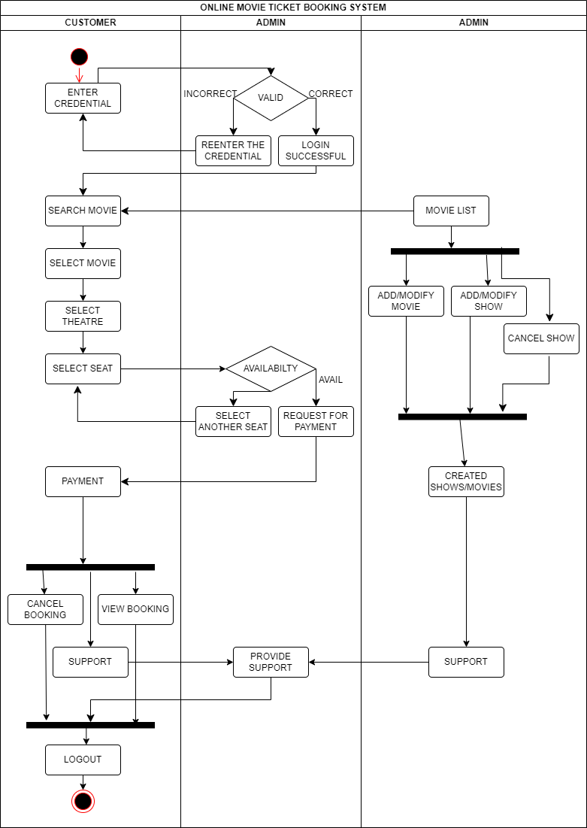Fig 5.2: Activity diagram of online movie ticket booking system

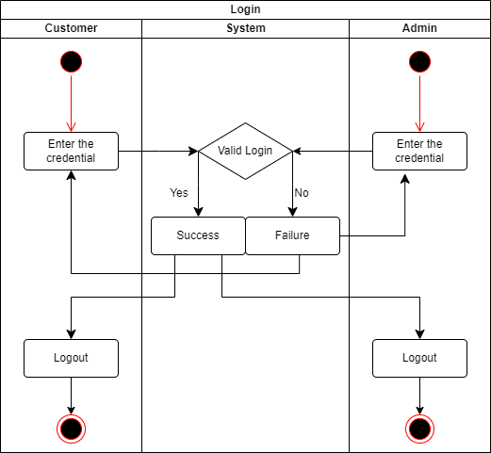

Fig 5.3: Activity diagram for Login

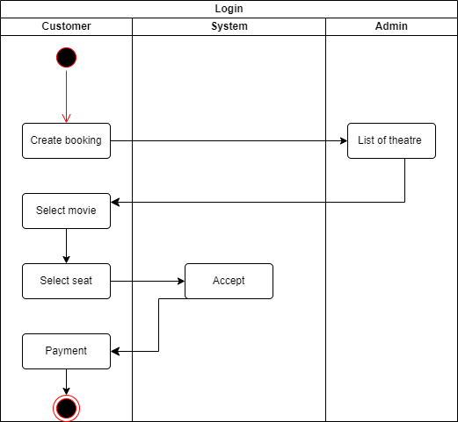

Fig 5.4: Activity diagram for Create booking

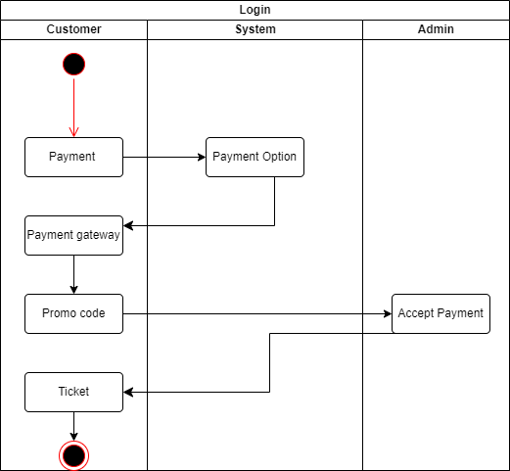

Fig 5.5: Activity diagram for Make payment

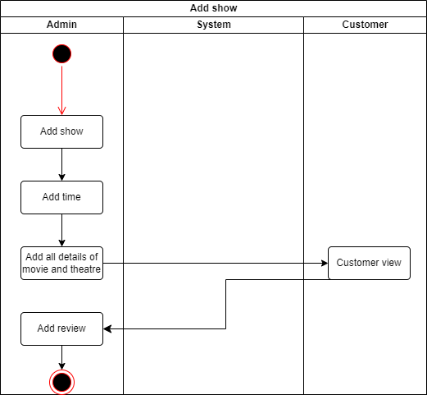

Fig 5.6: Activity diagram for Add show

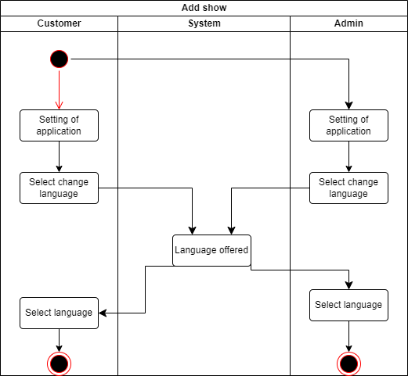

Fig 5.7: Activity diagram for Language Change

* 1. **STATE CHART DIAGRAM OF ONLINE MOVIE TICKET BOOKING SYSTEM**

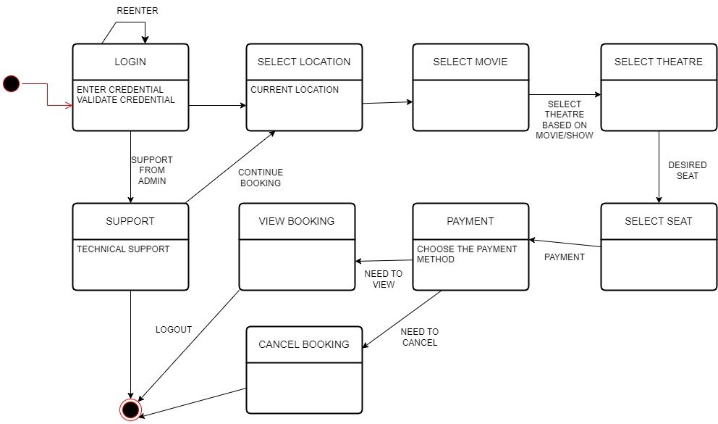

Fig 5.8: State Chart Diagram of online movie ticket booking system

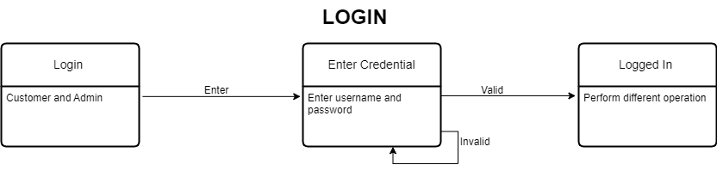

Fig 5.9: State Chart Diagram of Login

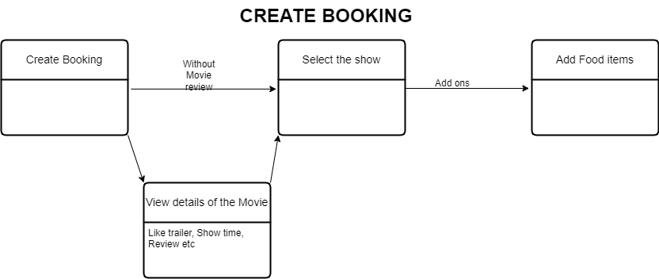

Fig 5.10: State Chart Diagram of Create booking

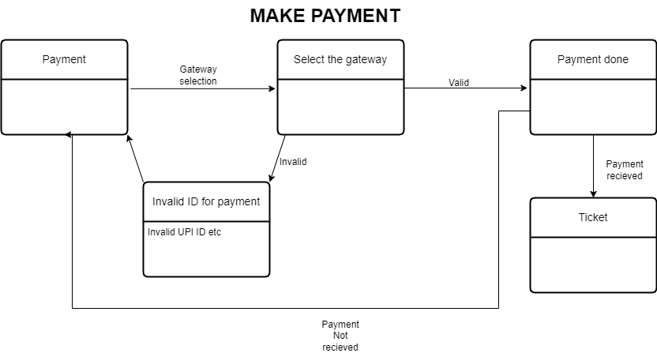

Fig 5.11: State Chart Diagram Make payment

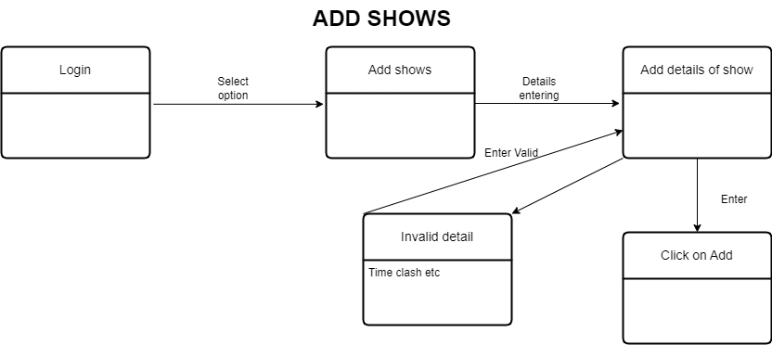

Fig 5.12: State Chart Diagram of Add show

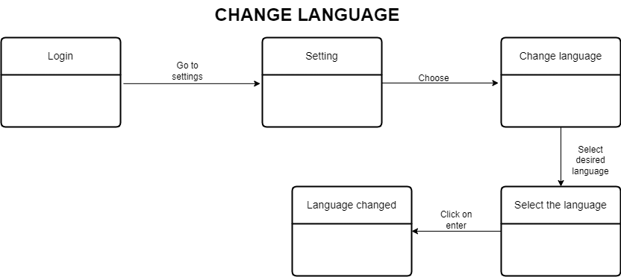

Fig 5.13: State Chart Diagram of Change language

**CHAPTER 06**

**VISION DOCUMENT**

**6.1 INTRODUCTION:**

This vision document contains user description, Product overview, Feature attributes, Product features, exemplary use cases etc. To create an online movie ticket booking system that makes it easy and convenient for moviegoers to purchase tickets for the latest films at their local cinemas, while also providing valuable insights and data to cinema owners to help them improve their operations and better serve their customers. A vision document for an online movie ticket booking system would outline the high-level goals and objectives of the project, as well as provide an overview of the system's key features and functionality.

**6.1.1 PURPOSE OF THE VISION DOCUMENT**

The purpose of the vision document for an online movie ticket booking system is to provide a clear and concise overview of the goals, objectives, and features of the system. The document serves as a roadmap for the development team, outlining the key priorities and guiding principles that will shape the project. The vision document helps to align stakeholders and ensure that everyone involved in the project understands the overall vision and purpose of the system. It also helps to manage expectations by providing a high-level overview of what the system will and will not do, and what benefits it will deliver to its target audience. Additionally, the vision document serves as a reference point throughout the development process, allowing the team to stay focused on the core objectives and features of the system, and providing a framework for making decisions and prioritizing tasks.

**6.1.2 PRODUCT OVERVIEW**

An online movie ticket booking system is a web-based platform that enables users to search for, select, and purchase tickets to movies showing at local cinemas. The system is designed to simplify and streamline the movie ticket booking process, making it easier and more convenient for users to purchase tickets online, anytime, and anywhere. The key components of an online movie ticket booking system include a user interface, a search engine, a database of movies and cinemas, a booking and payment system, and an administrative dashboard for cinema operators. The user interface is the front-end of the system and allows users to search for movies, select showtimes, choose seats, and purchase tickets. The search engine is responsible for finding movies based on a variety of criteria, including movie title, location, date, and genre. The database stores information about movies, cinemas, showtimes, and seating arrangements, and is updated in real-time to ensure accurate and up-to-date information is available to users. The booking and payment system allows users to select their desired movie, showtime, and seat, and pay for their tickets securely and conveniently using a variety of payment methods. The administrative dashboard allows cinema operators to manage their listings, update movie and showtime information, monitor ticket sales, and track customer data and feedback.

**6.1.3 REFERENCES**

A] Agarwal, S., Tiwari, N., & Dubey, M. (2017). Checking of Web Services Composition through Online Movie Ticket Booking Example. International Journal of Computer Science Research, 1-5.

B] AGBAEGBU, J., CALEB, C. V., & AYANGBEKUN, O. Design and Implementation of a Movie Reservation System.

C] DG, P. K., & KMB, P. (2020). Consumers’ Predilection towards Online Movie Ticket Booking System (With reference to bookmyshow. com in Davangere city). Studies in Indian Place Names.

D] Gomathi, P. and Madhavi, S., ANALYSING ONLINE MOVIE TICKET BOOKING SYSTEM

E] Pasyeka, M., & Malitchuk, A. (2020, October). Software Implementation of Movie Ticket Booking System. In 2020 IEEE International Conference on Problems of Infocommunications. Science and Technology (PIC S&T) (pp. 53 -56). IEEE.

F] Rajouria, R., Yadav, V., Mishra, R., Mishra, R., & Jain, S. (2015). Online Cinema Ticket Booking System. International Journal of Modern Engineering & Management Research, 3(1), 53-57.

G] Shaik, A., Kishor, R. C. K., Koduri, S. S., & Anisha, P. R. (2014, October). AMTS: Advanced Movie Ticketing System. In Proceedings of the 2014 International Conference on Information and Communication Technology for Competitive Strategies (pp. 1-4).

* 1. **USER DESCRIPTION:**

Users generally have a positive perspective on online movie ticket booking systems, as they provide a convenient and hassle-free way to purchase tickets for movies showing at local cinemas. Here are some of the key benefits that users appreciate about online movie ticket booking systems. One of the primary benefits of online movie ticket booking systems is convenience. Users can easily browse movie listings, select showtimes, and purchase tickets from the comfort of their own homes or on-the-go using their mobile devices. This eliminates the need to wait in long lines at the cinema, and allows users to avoid the hassle of purchasing tickets in person. Online movie ticket booking systems offer users flexibility in terms of selecting showtimes and seating arrangements. Users can view available seats in real-time and select the ones that best fit their preferences, ensuring that they get the seats they want for the movie they want to see. Online movie ticket booking systems can save users a significant amount of time, as they don't need to spend time traveling to the cinema or waiting in line to purchase tickets. Users can quickly and easily purchase tickets with just a few clicks, leaving them more time to enjoy other activities. Many online movies ticket booking systems offer personalized recommendations based on users' viewing history and preferences. This means that users can easily discover new movies that are likely to appeal to them, and can enjoy a more customized moviegoing experience. Some online movie ticket booking systems offer loyalty programs and other incentives to encourage repeat business. Users may be able to earn points or rewards for purchasing tickets, which can be redeemed for discounts on future purchases.

Overall, users appreciate the convenience, flexibility, and time-saving benefits of online movie ticket booking systems, as well as the personalized recommendations and loyalty programs that many systems offer.

**6.2.1 USER/MARKET DEMOGRAPHICS**

The key market demographic that motivates the design of online movie ticket booking systems is moviegoers who are looking for a convenient and hassle-free way to purchase tickets for movies showing at local cinemas. This demographic is typically tech-savvy and comfortable using digital platforms and mobile devices to access services and make purchases. Online movie ticket booking systems are particularly attractive to busy professionals, students, and families who value their time and are looking for ways to streamline their moviegoing experience. This demographic is likely to appreciate the convenience, flexibility, and personalized recommendations offered by online movie ticket booking systems. Additionally, cinema operators are motivated to adopt online movie ticket booking systems to increase their revenue and attract a larger audience. By providing a convenient and user-friendly platform for purchasing tickets, cinema operators can improve customer satisfaction and loyalty, while also gaining insights into customer behaviour and preferences that can inform their marketing and operational strategies.

**6.2.2 USER PROFILE**

The prospective users of online movie ticket booking systems are moviegoers who are interested in purchasing tickets for movies showing at local cinemas. These users are typically tech-savvy and comfortable using digital platforms and mobile devices to access services and make purchases. Prospective users may include a wide range of individuals, including busy professionals, students, families, and casual moviegoers. These users are likely to value their time and appreciate the convenience, flexibility, and personalized recommendations offered by online movie ticket booking systems. Some prospective users may also be motivated by loyalty programs or other incentives offered by online movie ticket booking systems, which can encourage repeat business and foster a sense of community among moviegoers. It is also worth noting that prospective users may vary in terms of their level of familiarity with technology and their preferences for how they prefer to access and interact with digital services. For example, some users may prefer to use a mobile app to book movie tickets, while others may prefer to use a desktop computer. Therefore, online movie ticket booking systems should be designed to accommodate a range of user preferences and needs, while also providing a seamless and user-friendly experience across all devices and platforms.

**6.2.3 USER ENVIRONMENT**

The user environment of an online movie ticket booking system typically consists of two main elements: the application and platform in use, and the specific usage model of the system. The application and platform in use refer to the software and hardware used by the user to access the online movie ticket booking system. This can include web browsers, mobile apps, and operating systems such as Android or iOS. The user environment should be designed to accommodate a range of different platforms, and should provide a consistent and user-friendly experience across all platforms. The specific usage model of the online movie ticket booking system refers to the way in which users interact with the system to book movie tickets. This can vary depending on the design of the system, but typically involves the following steps:

1. User selects the cinema they want to book tickets for.
2. The system displays a list of available movies and showtimes for that cinema.
3. User selects the movie and showtime they want to book.
4. The system displays a seating chart, where the user can select their preferred seats.
5. User selects their preferred seats and enters any additional details (e.g., number of tickets, concessions, etc.).
6. The system calculates the total cost of the tickets and displays the payment options.
7. User selects their preferred payment option and enters their payment information.
8. The system confirms the booking and sends a confirmation email or ticket to the user.
9. User arrives at the cinema, presents their ticket or booking confirmation, and enjoys the movie.

The user environment should be designed to be intuitive and easy to use, with clear and concise information provided at each step of the booking process. The system should also provide users with a range of features and functionality, such as the ability to search for specific movies, filter results by genre or date, and receive personalized recommendations based on their viewing history or preferences. The system should also be designed to provide users with a secure and reliable payment process, with robust security measures in place to protect user data and prevent fraud.

**6.2.4 KEY USER NEEDS**

Here are some key problems or needs as perceived by users in an online movie ticket booking system:

1. Difficulty in finding showtimes and availability: Users may have difficulty finding the showtimes and availability for a particular movie, especially during peak periods.
2. Limited seat selection: Users may find that the selection of available seats is limited or that their preferred seats are already taken.
3. Complex payment process: Users may find the payment process complex or confusing, especially if there are multiple payment options or additional fees.
4. Technical issues: Users may experience technical issues with the system, such as slow loading times, errors, or crashes.
5. Lack of transparency: Users may feel that the system lacks transparency, such as when it comes to pricing or seat availability.
6. Inconvenient user experience: Users may find the overall user experience to be inconvenient, such as when it comes to navigating the website or mobile app, or when booking tickets from multiple devices.
7. Limited movie selection: Users may find that the selection of movies available for booking is limited or does not meet their preferences.
8. Poor customer support: Users may experience poor customer support, such as when they encounter an issue with their booking or payment.

By addressing these key problems and needs, an online movie ticket booking system can provide a better user experience, increase customer satisfaction, and ultimately drive more bookings and revenue for the cinema or movie theatre.

**6.2.5 ALTERVATIVES AND COMPETITION:**

Some alternative options that users may perceive as available include:

1. Buying tickets at the cinema: Users may choose to buy tickets directly at the cinema, especially if they are already in the area or if they prefer to select their seats in person.
2. Using a different online ticket booking system: Users may be aware of and prefer to use a different online movie ticket booking system, if they perceive it to offer a better user experience or greater selection of movies.
3. Reserving tickets through third-party websites: Users may choose to reserve tickets through third-party websites, such as Fandango or Atom Tickets, which may offer additional features or promotions.
4. Waiting for the DVD or online streaming release: Users may opt to wait for the DVD or online streaming release of the movie, if they are not in a rush to see it in theatres or if they prefer the convenience of watching it from home.
5. Skipping the movie altogether: Users may choose to skip the movie altogether, especially if they perceive the price of the tickets to be too high or if they are not interested in the available movie selection.

By understanding the alternatives available to users, online movie ticket booking systems can better position themselves to meet user needs and differentiate themselves from competing options.

* 1. **PRODUCT OVERVIEW**

**6.3.1 PRODUCT PERSPECTIVE**

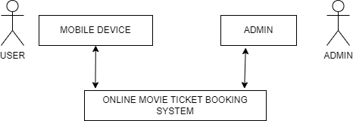

Fig 6.1: OVERVIEW OF PRODUCT PERSPECTIVE

**6.3.2 PRODUCT POSITION STATEMENT**

For the customer like seniors, young adult, families who are interested in movies are facing the problem in ticket booking. People are standing in queue to book their ticket in counter of theatre. This is the motivation to design the online movie ticket booking system. Customers can book movie tickets from anywhere, anytime, using any device with an internet connection. Cinemas and theatres can increase their revenue by reaching a wider audience and improving their ticketing process. We can also book ticket in person, using telephone call, third booking app or person, social media etc. Customers may have to wait in long lines at the box office, which can be time-consuming and frustrating, especially during peak movie-going times. Telephone booking can also be time-consuming, as customers may have to wait on hold for long periods of time, and there may be limited availability of customer service representatives to handle all the calls. While these websites can offer a convenient way to book movie tickets online, they may not always have accurate information about showtimes and availability.

**6.3.3 SUMMARY CAPABILTIES**

Table 6.1: Summary Capabilities

|  |  |
| --- | --- |
| CUSTOMER BENEFITS | SUPPORTING FEATURES |
| CONVENIENCE | Online accessibility of the booking system, which is available 24/7 |
| TIME SAVING | Customers no longer need to wait in long queues at the box office, saving time and reducing frustration. |
| ACCESS TO INFORMATION | Real-time availability of showtimes, seating plans, and movie information that customers can access at their fingertips. |
| SECURITY | Integration with secure payment gateways that protect customer payment information and personal data. |
| INCREASED REVENUE | Access to a larger customer base through the online platform and efficient ticketing operations that maximize revenue potential. |
| EFFICIENCY | Automated booking and payment processes that reduce human errors and improve the overall ticketing process. |
| PERSONALISATION | Integration with customer relationship management (CRM) systems that can personalize offers and recommendations for each customer. |

**6.3.4 ASSUMPTION AND DEPENDENCY**

Assumptions and dependencies are important considerations when developing and implementing an online movie ticket booking system. Here are some examples of assumptions and dependencies for this product:

**Assumptions:**

Users have access to a reliable internet connection to access the online movie ticket booking system. The system is accessible on a range of devices, including desktop computers, laptops, tablets, and smartphones. Users are willing to pay a service fee for the convenience of booking movie tickets online. The system can reliably retrieve and display up-to-date information about movie showtimes and availability from third-party data sources. The system can handle many simultaneous user requests, particularly during peak times such as weekends and holidays.

**Dependencies:**

The system relies on access to accurate and up-to-date information about movie showtimes, availability, and pricing from third-party data sources. The system depends on the availability and reliability of payment gateway providers to process user transactions securely. The system may require integration with other third-party applications or services, such as customer relationship management software or marketing analytics platforms. The system may depend on regular updates and maintenance to ensure continued performance, security, and user experience improvements. The success of the system depends on user adoption and engagement, which may be influenced by factors such as user interface design, ease of use, and overall customer satisfaction.

**6.3.5 COST AND PRICING**

While the exact cost of an online movie ticket booking system can vary widely depending on factors such as the size of the system, the number of features, and the level of customization required, here are some rough estimates:

Development cost: The development cost of an online movie ticket booking system can range from $5,000 to $50,000 or more, depending on the complexity of the system and the expertise of the development team.

Integration cost: The integration cost of an online ticket booking system can vary depending on the number of integrations required and the complexity of the integrations. A ballpark estimate for integration costs can be between $1,000 to $10,000.

Maintenance cost: The ongoing maintenance cost of an online ticket booking system can range from $100 to $1,000 per month, depending on the size and complexity of the system and the level of support required.

Pricing model: The pricing model for an online ticket booking system can vary, and there are several options to consider. For example, the system can be priced per ticket sold, a monthly subscription fee, or a commission percentage on the ticket price.

Overall, the cost of an online movie ticket booking system can range from $10,000 to $100,000 or more, depending on the size and complexity of the system and the level of customization required.

**6.4 FEATURE ATTRIBUTE**

Table 6.2: Feature attribute

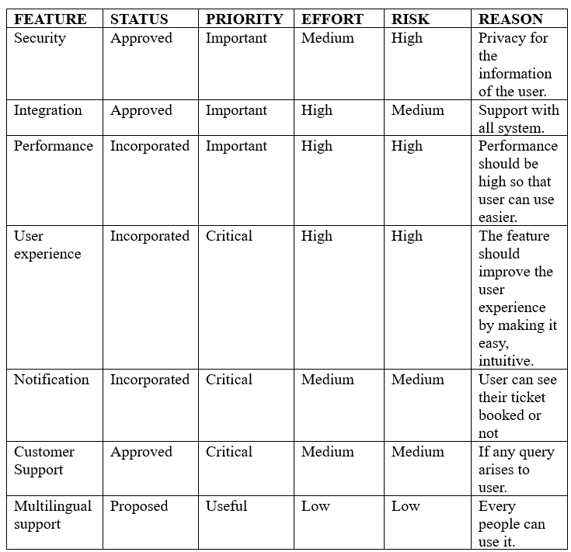

* 1. **PRODUCT FEATURE**

**6.5.1 SYSTEM FEATURE**

1. Movie listings: Users can browse and search for movies based on title, genre, rating, location, and other criteria.
2. Showtime listings: Users can view showtimes for movies at various theatres, select the desired showtime, and choose the seats they want.
3. Seat selection: Users can select their preferred seats for a given showtime, and view the seating chart for the theatre.
4. Payment gateway integration: The system should have integration with various payment gateways to enable secure and convenient payments.
5. User registration and login: Users can create an account to store their preferences and payment information, and access their transaction history.
6. Booking confirmation: After completing a booking, users receive a confirmation email or SMS with details of their booking.
7. Refund and cancellation: Users should be able to cancel or refund their bookings with a certain cancellation policy.
8. Ratings and reviews: Users can rate and review movies, theatres, and their overall experience with the booking system.
9. Mobile app: Many online ticket booking systems offer a mobile app for users to make bookings on-the-go.
10. Loyalty program: Some systems offer a loyalty program to incentivize users to use the system more often and provide them with discounts and other benefits.

**6.5.2 COMMUNICATION FEATURE**

1. Notifications: The system can send notifications to users regarding the booking status, ticket availability, show timings, and other important information related to their booking.
2. Chat support: The system can offer a chat support feature that allows users to communicate with customer support representatives in real-time. This feature can be particularly useful for users who have questions or issues related to their booking.
3. Email communication: The system can send email communication to users regarding their booking details, confirmation, cancellation, and other related information.
4. SMS alerts: The system can send SMS alerts to users regarding their booking status, show timings, and other important updates.
5. Social media integration: The system can integrate with social media platforms and allow users to share their booking details, write reviews, and provide feedback.
6. Help centre: The system can have a comprehensive help centre that provides users with detailed information about the booking process, frequently asked questions, and other related topics.

**6.5.3 EMERGENCY FEATURE**

1. Emergency contact information: The system can provide emergency contact information, such as a phone number or email address, that users can use to contact customer support or emergency services.
2. Refund and cancellation policy: The system can have a clear and transparent refund and cancellation policy in case of emergency situations such as illness, accidents, or natural disasters.
3. Priority booking: In case of an emergency, the system can offer priority booking to users to help them secure tickets for a different date or time.
4. Live support: The system can offer live support via chat or phone to assist users in case of emergency situations.
5. Notification system: The system can have a notification system that sends alerts to users in case of any emergency or urgent updates related to their booking.
6. Accessibility features: The system can have accessibility features such as subtitles, audio descriptions, or sign language interpretation for users who may have emergency situations related to their physical or cognitive abilities.

**6.6 EXEMPLARY USECASE**

The key use cases of an online movie ticket booking system are:

1. Convenience: Users can book movie tickets from anywhere and at any time, without having to visit the theatre in person or stand in long queues.
2. Seat selection: Users can select their preferred seats in advance and have a better movie experience by avoiding uncomfortable or obstructed views.
3. Real-time availability: Users can view the real-time availability of tickets for a particular show or movie and make informed decisions about their booking.
4. Multiple payment options: Users can choose from various payment options such as credit/debit cards, net banking, or mobile wallets, making the payment process quick and easy.
5. Discounts and offers: Users can avail of discounts and offers while booking their tickets, making it more affordable to watch movies.
6. Mobile app integration: Users can download a mobile app and use the online movie booking system on their smartphones, making it more convenient and accessible.
7. Refunds and cancellations: Users can cancel or reschedule their bookings in case of any emergency or unexpected situations.
8. Loyalty programs: Users can earn loyalty points and rewards by using the online movie booking system regularly, which can be redeemed for future bookings.
9. Feedback and ratings: Users can provide feedback and ratings after watching a movie, which can help other users make informed decisions while booking their tickets.
10. Social media integration: Users can share their movie booking details, reviews, and ratings on social media platforms, helping to promote the movie and the online booking system.

**6.7 OTHER PRODUCT REQUIREMENT**

**6.7.1 APPLICABLE STANDARDS**

Payment Card Industry Data Security Standards (PCI DSS): These standard outlines security requirements for organizations that handle credit and debit card information, ensuring the protection of sensitive customer data.

General Data Protection Regulation (GDPR): This regulation protects the privacy and personal data of individuals within the European Union, ensuring that organizations process and protect personal data in a lawful and transparent manner.

Web Content Accessibility Guidelines (WCAG): This standard provides guidelines for making web content accessible to people with disabilities, ensuring that the online movie ticket booking system can be used by all individuals, regardless of their abilities.

ISO 27001: This international standard outlines requirements for information security management systems (ISMS), ensuring that the online movie ticket booking system is secure and the information processed by the system is protected.

Health Insurance Portability and Accountability Act (HIPAA): These standard outlines privacy and security requirements for the protection of electronic protected health information (ePHI), ensuring that health-related data is processed and stored securely.

Open Web Application Security Project (OWASP): This standard provides guidelines for developing secure web applications, ensuring that the online movie ticket booking system is protected against common security threats such as cross-site scripting (XSS), SQL injection, and other attacks.

**6.7.2 SYSTEM REQUIREMENTS**

Operating System: The server hosting the online movie booking system should run a stable and secure operating system such as Linux or Windows Server.

Web Server: The web server should be able to handle many requests and support the necessary web technologies such as HTML, CSS, and JavaScript. Common web servers used for online movie booking systems include Apache, Nginx, and IIS.

Database Management System: The database management system should be scalable, secure, and capable of handling a large amount of data. Popular database management systems for online movie booking systems include MySQL, PostgreSQL, and Microsoft SQL Server.

Network Infrastructure: The network infrastructure should be reliable and capable of handling a large amount of traffic. It should also be secure to prevent unauthorized access to sensitive data. A load balancer can be used to distribute traffic across multiple servers to improve performance and reliability.

Security: The online movie booking system should be secured using best practices such as HTTPS, SSL/TLS encryption, firewalls, and intrusion detection systems. It should also comply with industry standards such as PCI DSS to protect sensitive customer data.

Hardware: The server hardware should be powerful enough to handle the expected traffic and data processing requirements of the online movie booking system. It should also be scalable to allow for future growth and expansion.

Mobile Application Support: The online movie booking system should support mobile devices, either through a mobile-responsive website or a dedicated mobile application. The mobile application should be compatible with both iOS and Android operating systems.

**6.7.3 LICENSING, SECURITY, AND INSTALLATION**

Licensing: If the online movie booking system uses third-party software components or libraries, it may require developers to obtain appropriate licenses and comply with license terms and conditions. Failure to comply with licensing requirements can result in legal and financial consequences, so it is important to ensure that all licensing requirements are met during development.

Security: The online movie booking system should be secured using various security measures such as encryption, firewalls, intrusion detection systems, and access controls. Meeting security requirements may involve additional development effort to implement secure coding practices, conduct security testing, and integrate security tools and technologies.

Installation: The installation process for the online movie booking system should be easy to use and require minimal effort from users. This may involve creating separate installation software or scripts to automate the installation process and ensure that all necessary components are installed correctly.

**6.7.4 PERFORMANCE REQUIEMENT**

Responsiveness: The system should respond quickly to user requests and load pages within a few seconds. Slow response times can lead to frustration among users and reduce the system's usability.

Scalability: The system should be able to handle many users and transactions without affecting performance. As the number of users increases, the system should be able to scale up to meet demand by adding additional resources such as servers or database instances.

Availability: The system should be available 24/7 to users. Downtime can result in lost revenue and dissatisfied customers, so it is important to ensure that the system is highly available and resilient to failures.

Reliability: The system should be reliable and free from errors that can cause data loss or corruption. This can be achieved by implementing data backup and recovery procedures, error handling mechanisms, and rigorous testing.

Security: The system should be secure and protect user data from unauthorized access, modification, or disclosure. This can be achieved by implementing security measures such as encryption, access controls, and secure coding practices.

Concurrency: The system should be able to handle multiple requests concurrently without affecting performance or causing data inconsistency. This can be achieved by implementing concurrency controls such as locks and transactions.

Throughput: The system should be able to handle many transactions per second to ensure that users can complete their transactions quickly and efficiently. This can be achieved by optimizing database queries, minimizing network latency, and using caching mechanisms.

**6.8 DOCUMENTATION REQUIREMENT**

**6.8.1 USER MANUAL**

The purpose of an online movie ticket booking system user manual is to provide users with a comprehensive guide on how to use the system effectively. The user manual should be written in simple language and provide step-by-step instructions on how to perform various tasks using the system. The content of the user manual may vary depending on the complexity of the system, but it typically includes the following sections:

1. Introduction: This section provides an overview of the online movie ticket booking system and its key features. It also includes information about the target audience for the user manual and the scope of the document.
2. Getting Started: This section provides instructions on how to access the system and create a user account. It also includes information about system requirements, supported browsers, and any other prerequisites.
3. User Interface: This section provides an overview of the user interface and its key components. It includes descriptions of buttons, menus, and other interactive elements, as well as instructions on how to navigate through the system.
4. Booking Tickets: This section provides step-by-step instructions on how to book movie tickets using the system. It includes information about selecting a movie, choosing a theatre and showtime, selecting seats, and making payments.
5. Managing Bookings: This section provides instructions on how to view and manage existing bookings, including cancelling or modifying a booking.
6. Frequently Asked Questions: This section provides answers to common questions that users may have about the system, such as how to reset a password or how to contact customer support.
7. Troubleshooting: This section provides information about common issues that users may encounter while using the system and provides solutions for resolving these issues.
8. Glossary: This section provides definitions for key terms and concepts used throughout the user manual.

**6.8.2 ONLINE HELP**

Accessibility: The online help and tooltips should be accessible to all users, including those with disabilities. This can be achieved by providing alternative text for images and ensuring that the content can be navigated using a keyboard.

Clarity: The online help and tooltips should be written in clear and concise language, using terms that are familiar to users. They should provide relevant information and instructions on how to perform specific tasks.

Availability: The online help and tooltips should be available throughout the system, providing users with quick access to information when they need it. They should be easily accessible from any page of the system, and users should be able to search for specific information.

Consistency: The online help and tooltips should be consistent in their format and layout, making it easy for users to recognize them and use them effectively.

Relevance: The online help and tooltips should be relevant to the context in which they are presented. They should provide information that is specific to the task or feature that the user is currently working on.

Interactivity: The online help and tooltips should be interactive, providing users with the ability to click on links or perform other actions to access additional information or perform tasks.

Customization: The online help and tooltips should be customizable, allowing users to adjust the font size, colour, and other settings to meet their needs.

**6.8.3 INSTALLATION GUIDE, CONFIG URATION, AND READ ME FILE**

Installation guide, configuration, and readme file will be given for the user and developer reference later.

**6.8.4 LABELING AND PACKAGING**

A consistent look and feel begins with product packaging and applies to installation menus, splash screens, help systems, GUI dialog boxes, and so on. This section defines the needs and types of labelling to be incorporated in the code. Examples include copyright and patent notices, corporate logos, standardized icons, and other graphic elements.

Labelling: The labelling for the online movie ticket booking system should include the product name, version number, and company logo. It should also include any required regulatory or compliance information, such as copyright notices or trademarks.

Packaging: The packaging for the online movie ticket booking system may include a physical box or an electronic delivery system, such as a download link or online access code. The packaging should be designed to protect the product during shipping and storage, and it should include any necessary instructions or documentation.

**6.9 GLOSSARY**

Table 9.3: Glossary for vision document

|  |  |  |
| --- | --- | --- |
| SNO | WORD | MEANING |
| 1 | User | An individual who browses movies, select seats, and purchase tickets. |
| 2 | Movie | A feature-length film that is currently showing or available for booking |
| 3 | Theatre | A physical location where movies are screened for audiences. |
| 4 | Showtime | A specific time at which a movie is scheduled to be screened at a particular theatre. |
| 5 | Seat | A physical space in a theatre where a user can sit and watch a movie. |
| 6 | Booking | The process of reserving one or more seats for a specific movie at a particular theatre and show time. |
| 7 | Payment | The process of exchanging money for a ticket or seat reservation on the online movie ticket booking system. |
| 8 | Confirmation | A message or notification that the user receives after completing the booking process and making a payment. |
| 9 | Cancellation | The process of cancelling a seat reservation or ticket on the online movie ticket booking system. |
| 10 | Refund | The process of returning money to the user's account after cancelling a seat reservation or ticket. |
| 11 | Account | A user's personal space on the online movie ticket booking system, where they can manage their bookings, payment methods, and personal information. |
| 12 | Notification | A message or alert that the user receives from the online movie ticket booking system regarding their booking status, payment status, or other updates. |
| 13 | Language | The specific language in which the user interface. |

**CHAPTER 07**

**SUPPLEMENTARY DOCUMENT**

**7.1 INTRODUCTION**:

**7.2.1 PURPOSE**

The purpose of an online movie ticket booking system is to provide a convenient and efficient way for users to book movie tickets online. This system allows users to browse available movies, select showtimes, choose their preferred seats, and complete the booking process securely and easily.

By providing a user-friendly interface and supporting multiple payment options, an online movie ticket booking system can help streamline the movie-going experience for users, reducing wait times at theatres and eliminating the need for users to visit physical box offices.

For theatre owners and operators, an online movie ticket booking system can help increase efficiency and reduce overhead costs associated with ticket sales. By automating the ticketing process, theatre staff can focus on providing excellent customer service and ensuring that the movie-going experience is enjoyable for all patrons.

In summary, the purpose of an online movie ticket booking system is to simplify the process of booking movie tickets, increase convenience for users, and improve efficiency and cost-effectiveness for theatre owners and operators.

**7.1.2 SCOPE**

The scope of an online movie ticket booking system includes the design, development, and implementation of a web-based platform that allows users to browse available movies, select showtimes, choose their preferred seats, and complete the booking process securely and easily. The system should also include support for multiple payment options and integrate with theatre booking and management systems to ensure that tickets are accurately reserved and seats are allocated correctly.

In terms of functionality, the system should allow users to search for movies by title, genre, or theatre location, view available showtimes, select their preferred seats, and complete the booking process in a few simple steps. The system should also include a user-friendly interface and support for multiple languages to ensure that it is accessible to users worldwide.

The scope of the project should also include testing, quality assurance, and ongoing maintenance and support to ensure that the system is reliable, secure, and performs as expected. The project should also include training for theatre staff on how to use the system and resolve any issues that may arise.

It is important to note that the scope of the project should be well-defined and realistic in terms of resources, timeline, and budget. This will help ensure that the project is completed successfully and meets the needs of its stakeholders.

**7.1.3 DEFINITIONS, ACRONYMS AND ABBREVIATIONS**

**Definitions:**

Online movie ticket booking system:

A web-based platform that allows users to browse available movies, select showtimes, choose their preferred seats, and complete the booking process securely and easily.

Theatre booking and management system:

A software platform used by theatre operators to manage ticket sales, allocate seats, and track attendance.

User account:

A personal account created by a user on the online movie ticket booking system to manage their booking history, payment options, and preferences.

Showtime:

A specific time and date for a movie screening.

Seat selection:

The process of choosing a specific seat or seats in a movie theatre for a particular showtime.

**Acronyms and Abbreviations:**

API: Application Programming Interface

SSL: Secure Socket Layer

UI: User Interface

UX: User Experience

CRM: Customer Relationship Management

OTA: Online Travel Agency

POS: Point of Sale

PMS: Property Management System

PII: Personally Identifiable Information

**7.1.4 REFERENCES**

[1] Shaik, A., Kishor, R.C.K., Koduri, S.S. and Anisha, P.R., 2014, October. AMTS: Advanced Movie Ticketing System. In *Proceedings of the 2014 International Conference on Information and Communication Technology for Competitive Strategies* (pp. 1-4).

[2] AGBAEGBU, J., CALEB, C. V., & AYANGBEKUN, O. Design and Implementation of a Movie Reservation System.

[3] Jamshed, M. B., & Afzal, W. (2016). *Online movie ticket reservation* (Doctoral dissertation, University of Management and Technology Lahore).

[4] Eneh, C. V. (2018). *DESIGN AND IMPLEMENTATION OF WEBBASED MOVIE TICKET RESERVATION SYSTEM* (Doctoral dissertation, Godfrey Okoye University).

[5] Guzman, M. M. F., Manaloto, J. A. B., Senina, A. D. D., & Portus, A. J. A. (2017). F6-2 Usability Testing of Online Movie Ticket Reservation in the Philippines. *The Japanese Journal of Ergonomics*, *53*(Supplement2), S592-S595.

[6] Sharma, A., & Dhiman, P. (2022). Movie Booking System.

[7] Ghosh, A. (2022). IBM Watson Assistant and Node-RED-Based Movie Ticketing Bot Design. In *Smart and Intelligent Systems: Proceedings of SIS 2021* (pp. 307-316). Springer Singapore.

[8] Rajouria, R., Yadav, V., Mishra, R., Mishra, R., & Jain, S. (2015). Online Cinema Ticket Booking System. *International Journal of Modern Engineering & Management Research*, *3*(1), 53-57.

[9] Roy, A., Shahdeo, V., & Kaluri, R. (2019). A Comparative Study in Online Movie Ticket Booking System. *Research Journal of Engineering and Technology*, *10*(1), 16-20.

[10] Akinyede, R. O., Balogun, T., & Iwasokun, G. (2017). Design and implementation of an online booking system for a cinema house. *Journal of Information and Computing Science*, *12*(2), 113-122.

**7.2 FUCTIONAL REQUIREMENTS**

More examples of potential functional requirements for an online movie ticket booking system:

Loyalty Program Integration:

The system could integrate with a loyalty program that rewards users with points or discounts based on their booking history or frequency. This could help incentivize users to continue using the system and increase customer retention.

Language Localization:

The system could support multiple languages and allow users to choose their preferred language for the booking process. This could be particularly useful for users who do not speak the system's default language fluently.

Accessibility Features:

The system could include accessibility features such as closed captioning, audio descriptions, and wheelchair-accessible seating options. This could help ensure that the system is accessible to all users, regardless of their abilities or disabilities.

Gift Card Redemption:

The system could allow users to redeem gift cards or promotional codes for discounted or free tickets. This could be a useful feature for users who have received gift cards as gifts or incentives.

Integration with Movie Reviews:

The system could integrate with a movie review platform such as Rotten Tomatoes or IMDb, allowing users to view movie ratings and reviews before booking their tickets. This could help users make informed decisions about which movies to see.

Mobile Application:

The system could offer a mobile application that allows users to book tickets on the go, view showtimes, and receive notifications about upcoming releases. This could be particularly useful for users who prefer to use their mobile devices for online transactions.

These are just a few more examples of potential functional requirements for an online movie ticket booking system. As with the previous examples, it is important to consider whether these requirements are essential for the system to function properly and meet its goals and objectives.

**7.3 USABILITY**

Here are some requirements that can affect the usability of an online movie ticket booking system:

User interface design:

The system should have an intuitive and user-friendly interface that allows users to easily navigate and complete the booking process. The user interface should be designed to minimize the number of clicks or steps required to complete a booking, and should provide clear instructions and feedback to users.

Navigation:

The system should have clear and consistent navigation that enables users to find the movies quickly and easily and showtimes they want to book. The navigation should also allow users to easily switch between different theatres and locations.

Mobile responsiveness:

The system should be designed to be mobile-responsive, meaning that it should work equally well on desktop and mobile devices. The interface should be optimized for smaller screens and touch-based input, and the booking process should be streamlined for ease of use on mobile devices.4

Seat selection:

The system should provide an easy-to-use interface for selecting seats, including the ability to select multiple seats at once and view a seating chart that shows available and unavailable seats.

Payment options:

The system should offer a variety of payment options that are easy to use and secure, including credit cards, PayPal, and other online payment systems.

Confirmation and feedback:

The system should provide clear and timely feedback to users, including confirmation of their booking, payment receipt, and any relevant instructions or information about the screening.

Overall, the requirements for an online movie ticket booking system should prioritize usability and user experience, in order to make it easy and enjoyable for users to find and book movies online.

**7.4 RELIABILTY**

Here are some requirements that can affect the reliability of an online movie ticket booking system:

Availability:

The system should be always available to users, with minimal downtime or maintenance windows. It should be designed to handle high traffic volumes, especially during peak movie-going periods.

Performance:

The system should perform consistently and quickly, with fast page load times and minimal lag or delays during the booking process. It should also be designed to handle unexpected traffic spikes or surges in demand.

Error handling:

The system should be designed to handle errors and exceptions gracefully, with clear error messages and notifications to users when problems occur. The system should also be designed to recover quickly from errors and restore normal operation.

Data integrity:

The system should ensure the integrity of user data, such as booking information and payment details, by using encryption and other security measures to protect against data breaches or unauthorized access.

Backup and recovery:

The system should have a robust backup and recovery strategy, with regular backups of all data and systems, and the ability to quickly restore the system in the event of a failure or outage.

Testing and monitoring:

The system should undergo rigorous testing and monitoring, including load testing, stress testing, and security testing, to ensure that it is reliable and secure. The system should also be monitored continuously for performance issues, errors, and other problems.

Overall, the requirements for reliability of an online movie ticket booking system should prioritize uptime, performance, data integrity, and recovery in the event of failures or outages. This will ensure that users can always access and use the system when they need it, without encountering errors or other problems that could impact their movie-going experience.

**7.5 PERFORMANCE**

Response time:

The system should have a fast response time, ideally less than 2 seconds for most user actions, such as loading a page or selecting a seat. This is especially important for use cases such as searching for movies and selecting seats, where users expect quick and responsive interactions.

Throughput:

The system should be able to handle a high throughput of user requests, especially during peak movie-going periods. This can be expressed quantitatively in terms of the number of concurrent users the system can handle, or the number of transactions it can process per minute or hour.

Scalability:

The system should be able to scale up or down to meet changes in demand, such as during holidays or blockbuster releases. This can be expressed quantitatively in terms of the number of servers or instances the system can spin up or down, or the maximum number of users it can handle simultaneously.

Availability:

The system should be always available to users, with minimal downtime or maintenance windows. This can be expressed quantitatively in terms of the system uptime, or the percentage of time the system is available to users.

Error rate:

The system should have a low error rate, ideally less than 1% of all user interactions. This can be expressed quantitatively in terms of the number of errors per hour or day, or the percentage of failed transactions.

Security:

The system should be secure and resistant to attacks, with a low vulnerability rate. This can be expressed quantitatively in terms of the number of security vulnerabilities discovered and fixed over time, or the percentage of successful attacks prevented by the system.

Overall, these performance characteristics should be designed to meet the needs of users and the demands of the movie ticket booking use case, ensuring that users can quickly and easily find and book movies online, without encountering performance or security issues.

**7.6 SUPPORTABILTY**

Here are some requirements that can enhance the system supportability or maintainability:

Modularity:

The system should be modular, with well-defined and independent components that can be modified or replaced without affecting other parts of the system. This can make it easier to maintain and upgrade the system over time, without disrupting its overall functionality.

Documentation: The system should be well-documented, with clear and concise documentation that explains the system's architecture, components, and processes. This can make it easier for developers and support staff to understand and maintain the system, even as it evolves over time.

Version control:

The system should be version-controlled, with a clear and organized history of changes and updates. This can make it easier to track changes over time, roll back to earlier versions if necessary, and collaborate effectively with other developers and stakeholders.

Testing and debugging tools:

The system should include testing and debugging tools, such as automated testing frameworks and debugging tools, that can help developers identify and fix issues quickly and efficiently.

Error logging and reporting:

The system should have robust error logging and reporting capabilities, with clear and detailed logs of errors and exceptions that can help developers diagnose and fix issues more easily.

Monitoring and alerting:

The system should be monitored continuously, with alerts and notifications set up to alert developers and support staff to any issues or problems that arise. This can help ensure that issues are addressed quickly and effectively, before they have a significant impact on the system or its users.

Overall, these requirements can help ensure that the system is supportable and maintainable over time, with a clear and organized structure, documentation, version control, testing tools, error logging and reporting, and monitoring and alerting capabilities. This can help minimize downtime, reduce the risk of errors and failures, and improve the overall quality and reliability of the system.

**7.7 DESIGN CONSTRAINTS**

Here are some possible design constraints that may affect the development and implementation of an online movie ticket booking system:

Technology stack:

The system must be developed using a specific technology stack or platform, such as a specific programming language, framework, or database management system. This can limit the choice of technologies and tools available for development, and may require specialized skills or expertise.

Integration with third-party services:

The system must integrate with third-party services or systems, such as payment gateways or movie databases. This can require adherence to specific APIs, protocols, or data formats, and may require additional testing and validation.

Performance requirements:

The system must meet specific performance requirements, such as response times, throughput, or scalability. This can require careful optimization and tuning of the system architecture, as well as selection of appropriate hardware or cloud resources.

Security requirements:

The system must meet specific security requirements, such as authentication, authorization, and data privacy. This can require adherence to specific security standards or regulations, as well as implementation of robust security controls and monitoring.

User interface design:

The system must adhere to specific user interface design standards or guidelines, such as accessibility or usability requirements. This can require close collaboration with user experience designers and testing with representative user groups.

Legal and regulatory compliance:

The system must comply with specific legal and regulatory requirements, such as data protection laws, consumer protection laws, or accessibility standards. This can require close collaboration with legal and regulatory experts, as well as careful documentation and testing to ensure compliance

.

Overall, these design constraints can affect the development and implementation of an online movie ticket booking system, requiring careful consideration, and planning to ensure that the system meets all requirements and constraints, while remaining functional, reliable, and user-friendly.

**7.8 DOCUMENTATION REQUIREMENT**

Here are some requirements for user and administrator documentation for an online movie ticket booking system:

User manuals:

The system should include user manuals that provide clear and concise instructions on how to use the system. The manuals should be easy to understand and should cover all aspects of the system, including account creation, ticket purchase, seat selection, and payment.

FAQs:

The system should include a list of frequently asked questions (FAQs) that address common user queries and issues. The FAQs should be comprehensive and easy to navigate, and should provide clear and concise answers to user questions.

Help videos:

The system should include help videos that provide step-by-step guidance on how to use the system. The videos should be short and focused, and should cover all major system features.

Admin manuals:

The system should include admin manuals that provide clear and concise instructions on how to manage the system. The manuals should cover all aspects of system administration, including user management, movie management, pricing, and promotions.

Technical documentation:

The system should include technical documentation that provides detailed information on the system architecture, components, and processes. The documentation should be comprehensive and easy to understand, and should cover all major system features and functionalities.

Training materials:

The system should include training materials that provide hands-on training to users and administrators. The training materials should be easy to follow and should cover all major system features and functionalities.

Overall, these requirements can help ensure that the system is well-documented and easy to use for both users and administrators. Clear and concise documentation can help reduce the learning curve for users and administrators, and can help minimize errors and issues during system use and administration.

**7.9 PURCHASED COMPONENETS**

Payment gateway:

The system may integrate with a third-party payment gateway, such as PayPal or Stripe, to process online payments. The payment gateway may require a license or subscription, and may charge a fee per transaction or a monthly fee.

Movie database:

The system may integrate with a third-party movie database, such as IMDb or TMDb, to retrieve movie information and images. The movie database may require a license or subscription, and may charge a fee based on usage or API calls.

Cloud hosting service:

The system may be hosted on a cloud hosting service, such as Amazon Web Services or Microsoft Azure, to ensure scalability and availability. The cloud hosting service may require a license or subscription, and may charge a fee based on usage or resource consumption.

Email service provider:

The system may use a third-party email service provider, such as SendGrid or Mailchimp, to send transactional and promotional emails. The email service provider may require a license or subscription, and may charge a fee based on the number of emails sent or the size of the email list.

SMS gateway:

The system may use a third-party SMS gateway, such as Twilio or Nexmo, to send SMS notifications and reminders. The SMS gateway may require a license or subscription, and may charge a fee per SMS or based on usage.

SSL certificate:

The system may use an SSL certificate to ensure secure communication between the server and client. The SSL certificate may require a license or subscription, and may need to be renewed periodically.

Overall, it is important to carefully consider the licensing and usage fees associated with any purchased components used with the system, and to ensure that all licensing terms and conditions are adhered to. Failure to do so could result in legal or financial penalties.

* 1. **INTERFACES**

**7.10.1 USER INTERFACE**

Responsive design: The user interface should be designed to be responsive and adaptive, so that it can be accessed and used seamlessly across multiple devices, such as desktops, laptops, tablets, and smartphones.

Simple and intuitive navigation: The user interface should feature a simple and intuitive navigation structure, with clear and visible menu options, buttons, and links, to help users easily find and access the features they need.

User-friendly forms and input fields: The user interface should include user-friendly forms and input fields, with clear and concise labels, tooltips, and error messages, to help users input and submit data accurately and efficiently.

Clear and informative feedback: The user interface should provide clear and informative feedback to users, such as confirmation messages, progress indicators, and error notifications, to help them understand the system status and respond appropriately.

Attractive and visually appealing design: The user interface should be designed to be visually appealing and attractive, with high-quality images, icons, and graphics, to engage users and enhance their user experience.

Accessibility features: The user interface should include accessibility features, such as keyboard shortcuts, screen reader compatibility, and high-contrast mode, to ensure that users with disabilities can access and use the system effectively.

**7.10.2 HARDWARE INTERFACE**

Web browsers: The application must be accessible through standard web browsers, such as Google Chrome, Mozilla Firefox, Microsoft Edge, and Apple Safari. The system should be compatible with the latest versions of these web browsers, as well as with previous versions if necessary.

Mobile devices: The application must be accessible through mobile devices, such as smartphones and tablets. The system should be compatible with popular mobile operating systems, such as Android and iOS, and should be optimized for different screen sizes and resolutions.

Point-of-sale devices: The system may need to support point-of-sale (POS) devices, such as card readers and scanners, to process payments and validate tickets. The system should be compatible with standard POS hardware, and should provide clear instructions for device setup and usage.

Printers: The system may need to support printers to print tickets, receipts, and other documents. The system should be compatible with standard printers, and should provide clear instructions for printer setup and usage.

Network devices: The system may need to support network devices, such as routers and switches, to ensure reliable network connectivity. The system should be compatible with standard network hardware, and should provide clear instructions for device setup and usage.

**7.10.3 SOFTWARE INTERFACE**

Operating system interface: The application should be compatible with the operating system on which it will be installed. This may include support for Windows, Mac, Linux, or other operating systems.

Database interface: The application should be able to interact with the database management system (DBMS) used to store and retrieve data. This may include support for MySQL, PostgreSQL, Oracle, MongoDB, or other DBMS.

Web interface: The application may need to support interaction with web browsers, including rendering web pages and accepting user input. This may include support for major web browsers such as Chrome, Firefox, Safari, and Edge.

Payment gateway interface: The application may need to interact with a third-party payment gateway to process online payments. This may include support for APIs provided by payment gateways such as PayPal, Stripe, or Braintree.

Email and SMS gateway interface: The application may need to interact with third-party email and SMS gateways to send notifications and reminders. This may include support for APIs provided by email and SMS gateways such as SendGrid, Twilio, or Nexmo.

Social media interface: The application may need to interact with social media platforms, such as Facebook, Twitter, or Instagram, to enable users to share movie information or purchase tickets through social media.

**7.10.4 COMMUNICATION INTERFACES**

Web interface: The system should have a web-based interface that allows users to access the system from any web-enabled device, such as a desktop computer, laptop, or mobile phone. The web interface should be responsive, intuitive, and user-friendly, with clear navigation and easy-to-use controls.

API interface: The system may need to support an API interface that allows other applications and systems to access and interact with the system programmatically. The API interface should be well-documented, secure, and scalable, with clear guidelines and usage limits.

Database interface: The system should have a database interface that allows the application to store and retrieve data from a database. The database interface should be reliable, efficient, and scalable, with clear rules.

Messaging interface: The system may need to support a messaging interface that allows users to send and receive messages, notifications, and alerts. The messaging interface should be reliable, secure, and scalable, with clear rules and guidelines for message delivery and management.

**7.11 LICENSING AND SECURITY REQUIREMENT**

Licensing Requirements:

The system should comply with all relevant licensing laws and regulations. The system should use only licensed software and components. The system should have a clear licensing agreement that outlines the terms and conditions of use. The system should ensure that all licenses are up-to-date and valid.

Security Requirements:

The system should ensure secure communication between the client and server using SSL/TLS encryption. The system should have strong access controls to prevent unauthorized access to sensitive data. The system should implement measures to prevent SQL injection attacks and other common security vulnerabilities. The system should have a clear security policy that outlines security measures, procedures, and responsibilities. The system should have a backup and recovery plan to ensure continuity of service in case of a security breach or disaster. The system should undergo regular security audits and vulnerability assessments to identify and address security risks.

Overall, it is important to ensure that both licensing and security requirements are integrated into the design and implementation of the system, and that they are regularly reviewed and updated as needed to ensure compliance and mitigate risk.

**7.12 LEGAL, COPYRIGHT, AND OTHER NOTICES**

Legal disclaimers, warranties, copyright notices, patent notices, trademarks, and logos are important elements that should be included in an online movie ticket booking system to protect the intellectual property of the system and to inform users of their rights and responsibilities. Here are some examples of each:

Legal Disclaimers: The system may include a legal disclaimer that outlines the limitations of liability for the system provider, and clarifies the terms and conditions of use.

Warranties: The system may include warranties that provide assurance to users that the system will function as intended and will meet their needs.

Copyright Notices: The system may include a copyright notice to inform users that the system is protected by copyright law and that unauthorized use or reproduction is prohibited.

Patent Notices: The system may include a patent notice to inform users that the system includes patented technology and that unauthorized use or reproduction is prohibited.

Trademarks and Logos: The system may include trademarks and logos to identify the system and its components, and to prevent unauthorized use or reproduction.

**7.13 APPLICABLE STANDARD**

ISO/IEC 12207: This is a standard for software life cycle processes that provides guidance on the development, operation, and maintenance of software systems. Sections 4, 5, and 6 are particularly relevant for the design, implementation, and testing of the system.

ISO/IEC 9126: This is a standard for software quality that defines a framework for evaluating software characteristics such as functionality, reliability, usability, efficiency, maintainability, and portability. This standard can be used to ensure that the system meets the required quality standards.

OWASP Top 10: This is a widely recognized standard for web application security that identifies the top 10 security risks that web applications may face. This standard can be used to identify and mitigate potential security risks in the online movie ticket booking system.

PCI DSS: This is a standard for payment card industry security that outlines a set of security requirements for organizations that handle credit card data. If the online movie ticket booking system involves payment transactions, compliance with this standard is essential to ensure the security of payment card data.

By referencing these standards and their relevant sections, the online movie ticket booking system can be designed and implemented to meet industry best practices and quality standards, and to ensure the security and reliability of the system.

**7.14 INTERNATIONALIZATION AND LOCALIZATION**

Language Support: The system should support multiple languages and dialects to cater to users from different regions. The user interface, error messages, and help documentation should be available in the languages that the users prefer.

Localization: The system should be able to adapt to the cultural and linguistic differences of different regions. For example, date and time formats, currency symbols, and address formats may differ from one region to another.

Language Detection: The system should be able to detect the user's language and adjust the interface and content accordingly. This can be done automatically by analyzing the user's IP address, browser settings, or other user information.

Translation Management: The system should have a mechanism to manage translations and updates to different languages and dialects. This can involve a translation management system or a team of translators to ensure that the translations are accurate and up-to-date.

Accessibility: The system should be designed with accessibility in mind, which includes support for assistive technologies such as screen readers and keyboard navigation. This is particularly important for users with visual impairments or other disabilities.

**7.15 PHYSICAL DELIVARABLE**

There are several specific deliverables or artifacts that may be required by the user or customer for an online movie ticket booking system. Here are some examples:

User Manuals: These are written documents that provide instructions on how to use the system. User manuals should be provided for both end-users and administrators, and should be available in different languages if required.

Installation Guides: These are documents that provide step-by-step instructions for installing and configuring the system. Installation guides should be available for different platforms (e.g., Windows, Linux, MacOS), and should include system requirements and any dependencies.

User Interface Design: This includes mockups, wireframes, or prototypes of the user interface that illustrate the layout, flow, and functionality of the system. User interface design should be reviewed and approved by the user or customer before implementation.

Test Plans and Reports: These are documents that outline the testing strategy, test cases, and expected results for the system. Test reports should document the results of testing, including any bugs or issues that were discovered.

System Documentation: This includes technical documents such as system architecture, database schema, and API documentation. System documentation should be comprehensive and detailed enough for developers to understand the system's inner workings.

Training Materials: These are documents or presentations that provide training to end-users or administrators on how to use the system. Training materials should be clear, concise, and easily understandable.

By providing these deliverables, the user or customer can have a better understanding of the system's functionality, usage, and maintenance requirements. This can lead to a better user experience and increased customer satisfaction.

**7.16 INSTALLATION AND DEPLOYMENT**

To ensure successful installation and deployment of the online movie ticket booking system, specific configuration and target system preparation are required. Here are some examples:

System Requirements: The system should have a detailed list of system requirements that includes the hardware, software, and network components required for installation and operation of the system. The system requirements should be communicated clearly to the customer to ensure that the target system meets the requirements.

Installation Procedure: The system should have a step-by-step installation procedure that includes the installation of all necessary components, including software and hardware. The installation procedure should be well-documented, including screen shots and illustrations, to ensure that the customer can follow the procedure easily.

Configuration Management: The system should have a configuration management plan that includes the management of configurations and changes to the system. This includes documentation of configuration settings, change control procedures, and version control.

Backup and Recovery: The system should have a backup and recovery plan that includes backup procedures, recovery procedures, and disaster recovery procedures. The backup and recovery plan should be tested regularly to ensure that it is effective and up-to-date.

Security Configuration: The system should have a security configuration plan that includes the configuration of security settings and access controls. This includes the configuration of firewalls, encryption, user accounts, and password policies.

Performance Tuning: The system should be tuned for optimal performance, including the configuration n of hardware and software components, database settings, and network settings. The performance tuning plan should be tested and validated to ensure that the system can handle the expected load.

By considering these specific configuration and target system preparation requirements, the online movie ticket booking system can be installed and deployed successfully, ensuring a smooth and error-free experience for the end-users.

**CHAPTER 08**

**CONCLUSION AND FUTURE WORKS**

**CONCLUSION**

In conclusion, the online movie ticket booking system has transformed the way people purchase movie tickets. It has not only made the process more convenient and user-friendly, but it has also enabled movie theatres to optimize their operations, improve their customer service, and increase their profits. The system has simplified the booking process for users by allowing them to book their tickets online from anywhere and at any time. Users can choose their preferred movie, theatre, and seats, and pay for their tickets securely using various payment options.

Moreover, the online movie ticket booking system has enabled movie theatres to track their ticket sales, manage their inventory, and analyze their customer behavior. This has allowed them to make data-driven decisions that optimize their operations, improve their profitability, and enhance their customer experience. Looking to the future, the online movie ticket booking system has enormous potential for further innovation and improvement. By leveraging emerging technologies like VR, machine learning, and blockchain, the system can provide an even more seamless and personalized experience for moviegoers. The system can also continue to evolve to meet the changing needs of the industry, such as integrating with smart devices and providing advanced security features.

Overall, the online movie ticket booking system has played a significant role in modernizing the movie industry, and with continued development and innovation, it will continue to provide a more convenient, efficient, and enjoyable movie-going experience for everyone.

**FUTURE WORK**

Here are some additional future work ideas for the online movie ticket booking system:

1. Virtual Reality: Incorporating virtual reality (VR) into the online movie ticket booking system can provide a unique and immersive experience for users. Users can explore movie theatres and choose their preferred seats through a VR headset.
2. Machine Learning: Machine learning algorithms can be used to predict the popularity of movies and optimize ticket pricing based on factors such as genre, actor, and release date.
3. Voice Assistants: The system can be integrated with voice assistants like Amazon's Alexa and Google Assistant to enable users to book movie tickets using voice commands.
4. Augmented Reality: Augmented reality (AR) can be used to enhance the movie viewing experience. Users can point their smartphones at movie posters and get additional information like trailers, cast and crew, and reviews.
5. Blockchain: Incorporating blockchain technology can provide a secure and transparent platform for movie ticket sales. It can prevent ticket fraud and ensure that tickets are sold at fair prices.
6. Localization: The system can be localized to cater to different regions and languages, making it more accessible to a wider audience.

**CHAPTER 09**

**REFERENCE**

**REFERENCE**

[1] Shaik, A., Kishor, R.C.K., Koduri, S.S. and Anisha, P.R., 2014, October. AMTS: Advanced Movie Ticketing System. In *Proceedings of the 2014 International Conference on Information and Communication Technology for Competitive Strategies* (pp. 1-4).

[2] AGBAEGBU, J., CALEB, C. V., & AYANGBEKUN, O. Design and Implementation of a Movie Reservation System.

[3] Jamshed, M. B., & Afzal, W. (2016). *Online movie ticket reservation* (Doctoral dissertation, University of Management and Technology Lahore).

[4] Eneh, C. V. (2018). *DESIGN AND IMPLEMENTATION OF WEBBASED MOVIE TICKET RESERVATION SYSTEM* (Doctoral dissertation, Godfrey Okoye University).

[5] Guzman, M. M. F., Manaloto, J. A. B., Senina, A. D. D., & Portus, A. J. A. (2017). F6-2 Usability Testing of Online Movie Ticket Reservation in the Philippines. *The Japanese Journal of Ergonomics*, *53*(Supplement2), S592-S595.

[6] Sharma, A., & Dhiman, P. (2022). Movie Booking System.

[7] Ghosh, A. (2022). IBM Watson Assistant and Node-RED-Based Movie Ticketing Bot Design. In *Smart and Intelligent Systems: Proceedings of SIS 2021* (pp. 307-316). Springer Singapore.

[8] Rajouria, R., Yadav, V., Mishra, R., Mishra, R., & Jain, S. (2015). Online Cinema Ticket Booking System. *International Journal of Modern Engineering & Management Research*, *3*(1), 53-57.

[9] Roy, A., Shahdeo, V., & Kaluri, R. (2019). A Comparative Study in Online Movie Ticket Booking System. *Research Journal of Engineering and Technology*, *10*(1), 16-20.

[10] Akinyede, R. O., Balogun, T., & Iwasokun, G. (2017). Design and implementation of an online booking system for a cinema house. *Journal of Information and Computing Science*, *12*(2), 113-122.